Webpage Documentation (Theme project settled: Planets)
Not sure of what Lavi and 4th teammate might do. Attempt to save project Armageddon

Overview
Okay so this is the overview for this project. Me and my teammate iso Have established ourselves into doing a web page based on planets. Iso will be focusing himself on creatin a Web app using web assembly and eternal libraries. And I will be creating te front landing page for the project. So the idea is to make the we app as interactive as possible.
Log 21/10/26 and time I try to finish the basic components for the landing page is in aproimattley 4 days. However deadline for this proect is due 30/10/26

Requirments

Must have
Each of the pages authored by individual team members must have (and therefore, each student must show their ability to author)
- HTML and content sufficient to create a professional-looking page
- One or more relevant images (these do not need to be original to you), displayed at selectable sizes (eg small, large etc).
- A menu, with clickable links to the other pages on the site.
- One or more of the images must link to another page or an external web site when clicked.
- One or more external CSS stylesheets.
- Use of classes and ids to apply suitable CSS formatting to elements on the page.
- Use of JavaScript to update HTML elements other than image size in response to user input such as mouse clicks or keystrokes.
- Use of an external JavaScript file.

Should Have
- CSS stylesheets that are shared between all pages, helping the whole site to have a more consistent “look and feel”.
- One or more uses of external JavaScript files that are utilised by all pages of the site. For example, the page menu might be a shared item.
- One or more buttons, leading to some user interaction facility.
- Use of JavaScript objects

Could Have
- Use of bootstrap classes to ensure your site is responsive.
- Use of JavaScript arrays or collections.(done with team member Iso)
- Non-trivial use of some other advanced feature (discuss with your tutor first).

The above bullet points are The assessment criteria. My main requirement is to link all the pages of my team and get 100 as a team and not be marked as individuals. From reading the criteria I will mark the points I see as the most valid in green and essential requirement in green and moderate requirments in orange and the could do essential in red


Idea Template of Landing page
Earth
Sun
Moon
Planets
Planets
Home Isopg lavipg 4thpg
Planet Details
Earth
EARTH

Project Start

Creating Environment

I have chosen Vs code as my tet editor for html instead of sublime text as I find using Vs code more appealing to use. I Then installed their extension for bootstrap
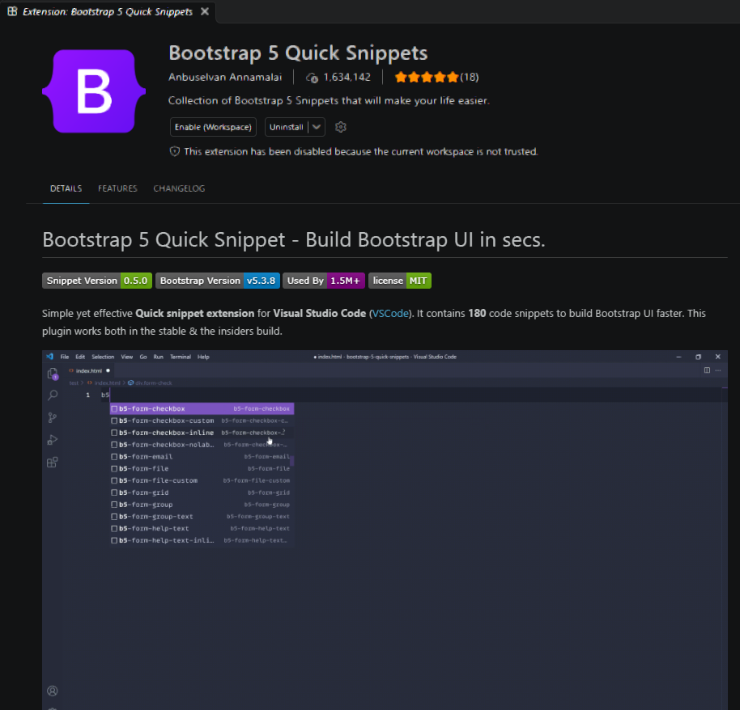
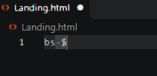 This creates the boiler plate for the HTML for bootstrap
I rearranged the boiler plate structure to how I want to layout my HTML page and also note that I have called 2 public API’s one for fonts and the other for bootstrap and also the scrip API for bootstrap
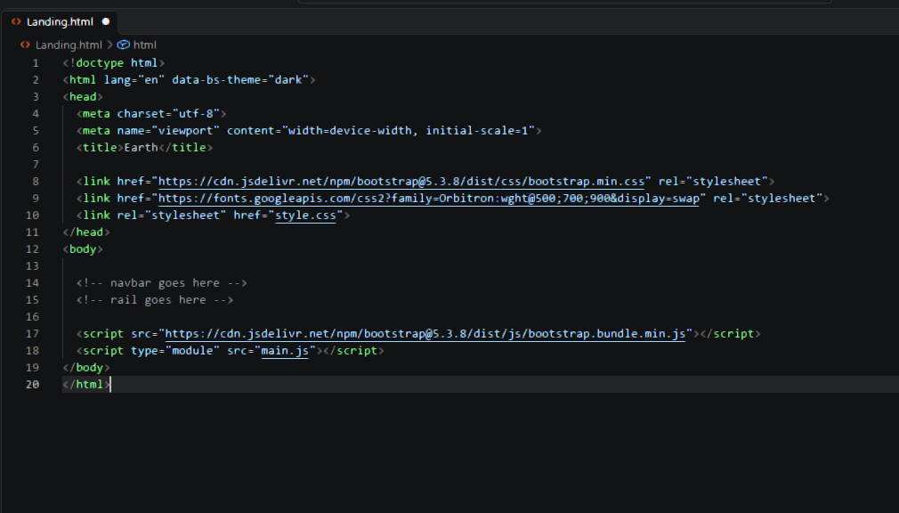

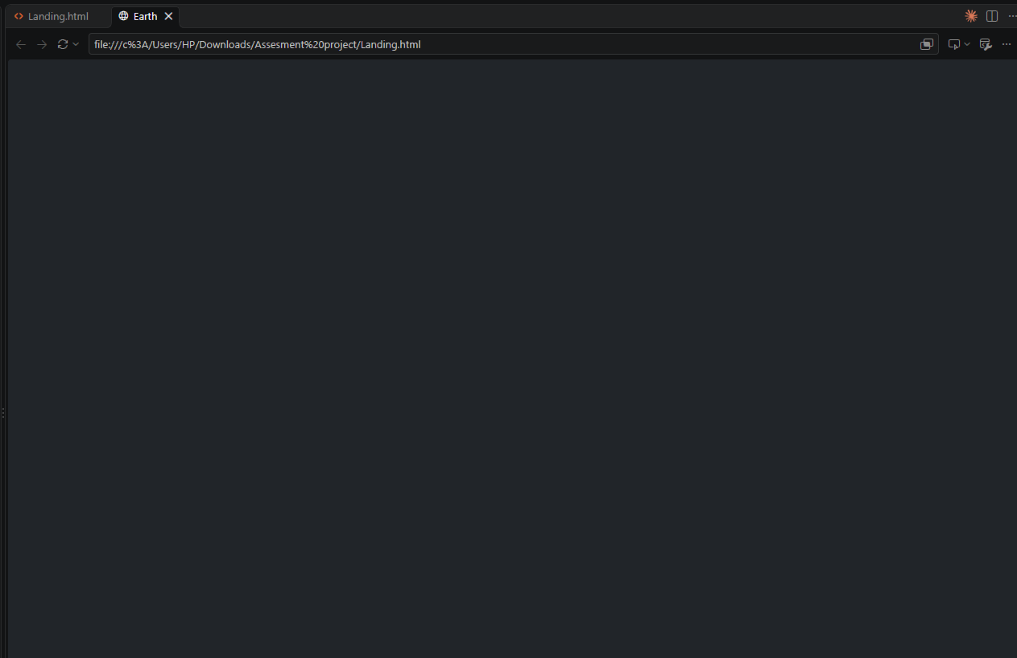
Currently webpage is empty and in dark theme as that’s what I have chosen for my default bootstrap theme

Creating Nav Bar

Well technically this is a really easy implementation and I will call in bootstaps inbuilt navbar templates from Visual studio and then arrange it to what I want
Nav bar template was taken and I implemented this inside the Body
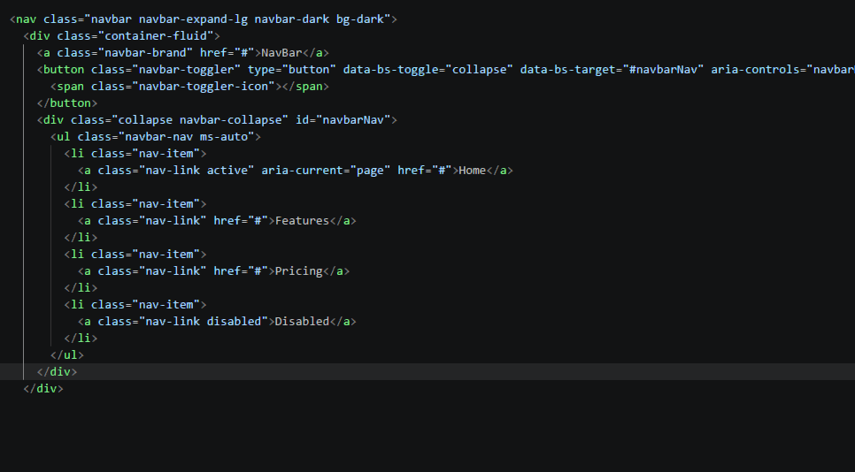
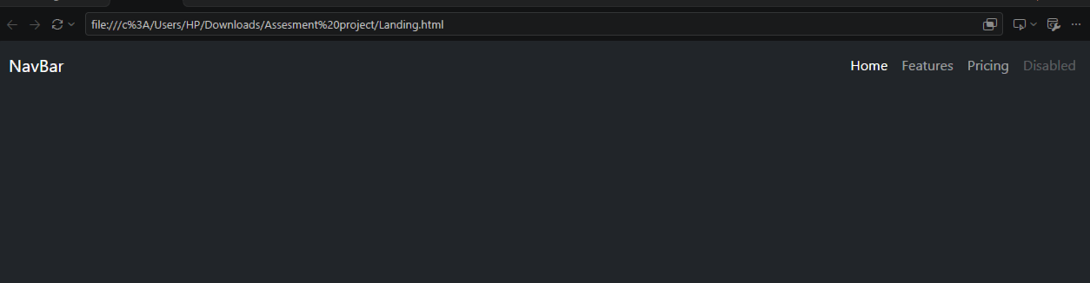

First I have to edit It’s contents

And then next thing I have to do is centralize the nav bar content
I create another div inside the container called navside
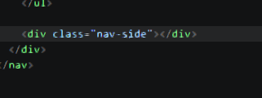

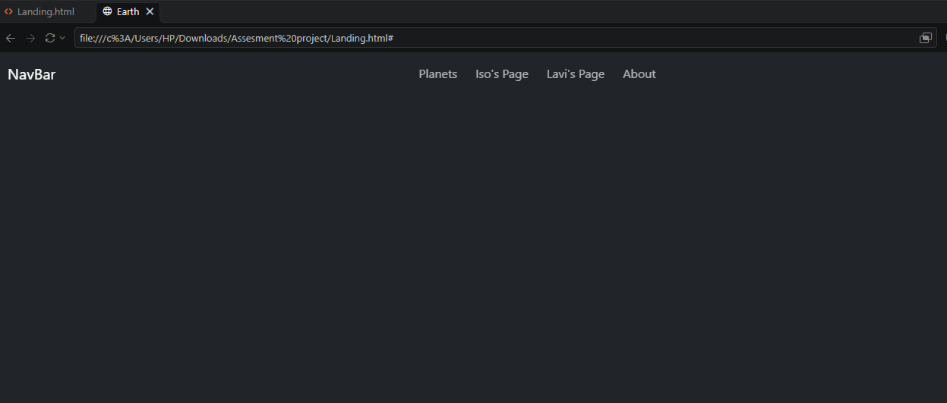

Styling Navbar
So the created components are the body,nav bar ,nav brand and the class nav link these are for the in odered list to act as a component giving us the toggle effects when moving between pages

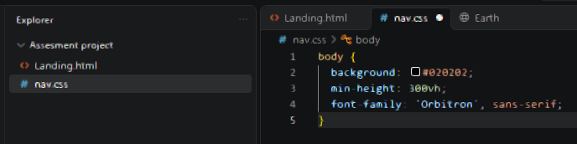
I created the background of the body to be defauld black
And gave a suitable verticle height for it to be scrollable it didn’t over stretch the verticle height of body for now. And gave a default fornt family th

NEXT WE WILL E USING PROPERTY VARABLE VALUES from Bootstrap to hel us contain our color values of our branding class and the nav bar class
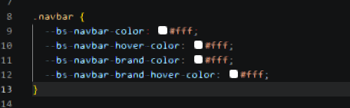
And next I created the styles for the brand and the items in navbar inside the clas of nav-link
I gave the font decorations and for the nav-link hover I decorated it with a defined function of bootstrap called underline to get the underline effect on hover

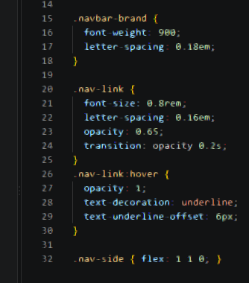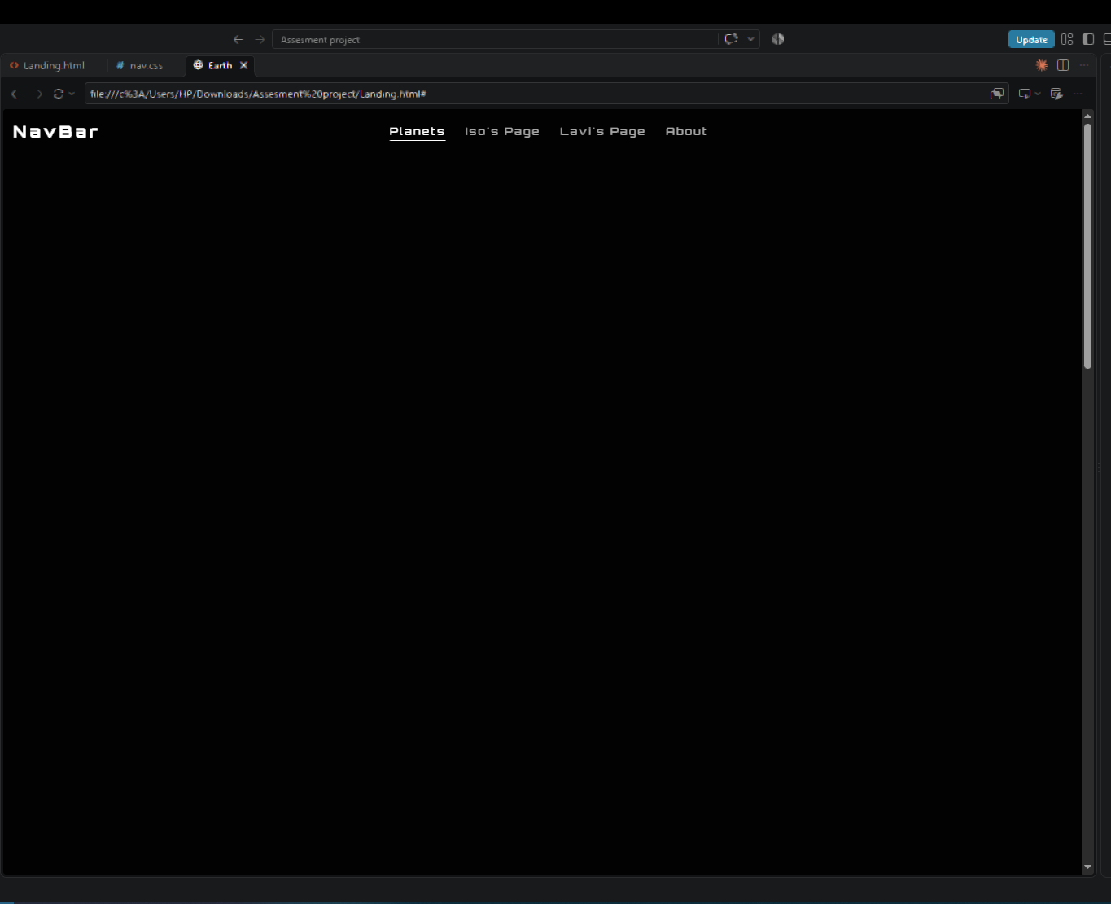

Rail Side Bar
For this I will be using the aside tag to situate the bar on the side and I will leave the in order function as it is because items will be displayed in a column
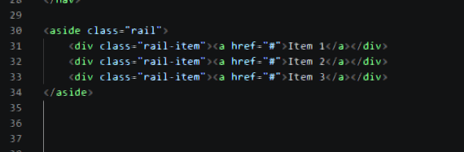
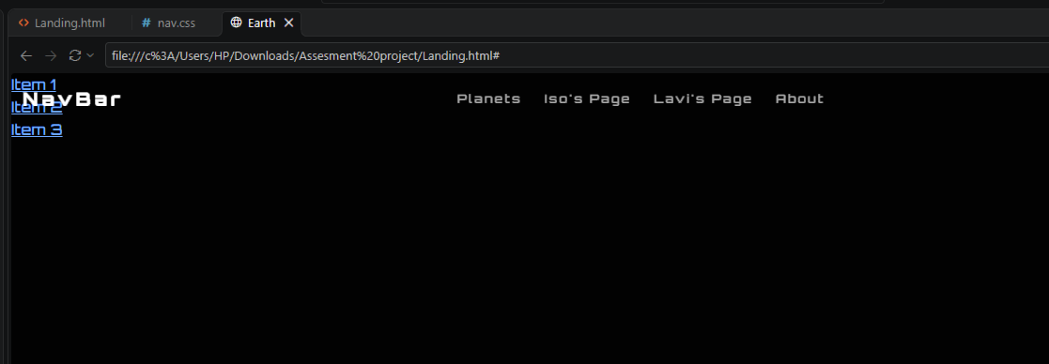
Next ill be rewriting items
I also created place holder html files for the planets(for now one), a star and a sattalite
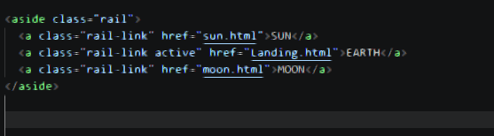

I am going to write the rail css in another css file to make my css files look clutter free
In this like I did earlier the css is almoast the same. The only difference is I have to set the container start point below the nav bar. So I use the root attr and give the bave bar height a value of 5 piels
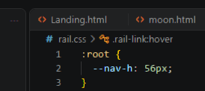
Next like I did with the nav bar im going to make definite container hold as a colum and style the values inside the rail via class rail-link and the decorations for on hover of mouse
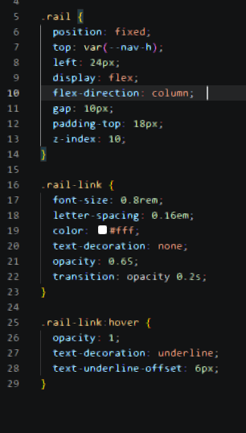
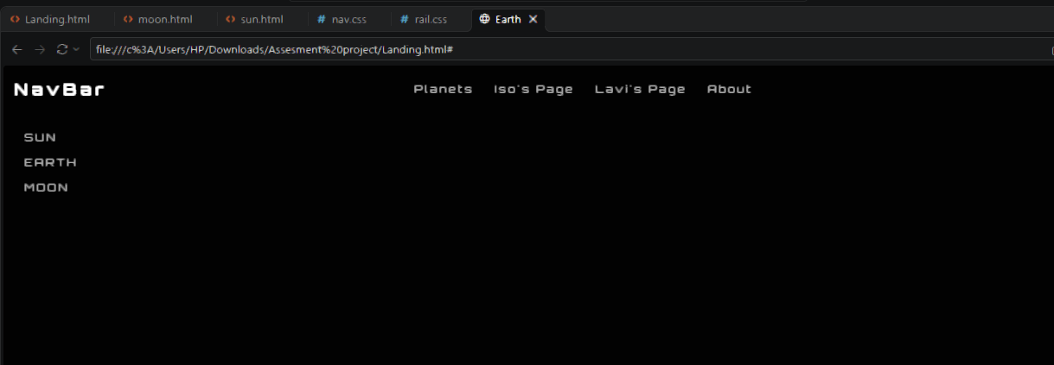
I want to make the page that is active highlighted that’s why I have set the opaqnes to 0.65
And now I write the instance for when its active to fully be opaqe
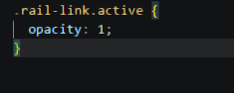
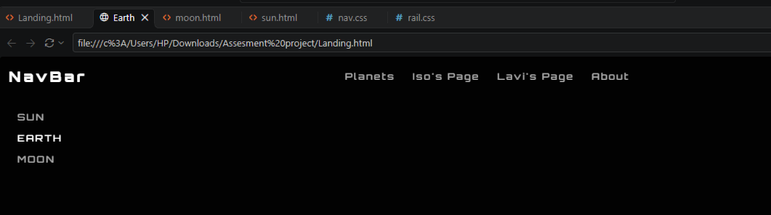

Creating planets and rotary motions

When I was researching for 3d object implementation for html. I came a cross the java script library for 3d objects called three.js. I found and online resource that had done something similar to what iwant to make https://threejsresources.com/showcase/star-field-experiment . This resource showed me the understanding requirement to creating a particle and it’s structure. The understanding to help understand how to create a particle is by.
- We have to call the script API for three.js . u can get the API address from npm such as jsdelivr.net

- I used a youtube video to help me understand setting up three.js in an HTML <canvas>. All I have to do for creating the canvas is I can choose if I want to create the canvas in an eternal css or an internal. Ut for this project the canvas declaration as with the video I followed shows declaring in an external file and then creating the canvas via the js file as writing it through the document.body.append method.

- Declaring canvas in style.css
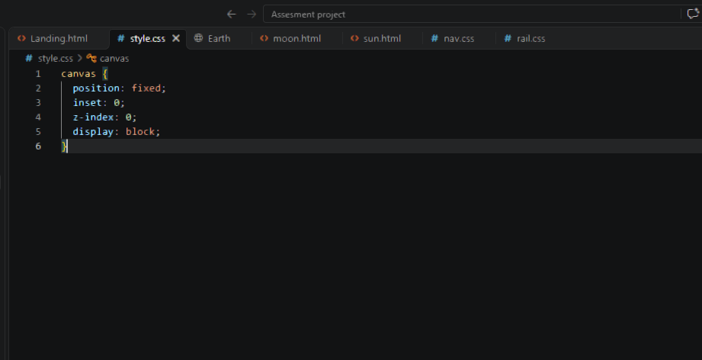
- Writing the 3d canvas renderer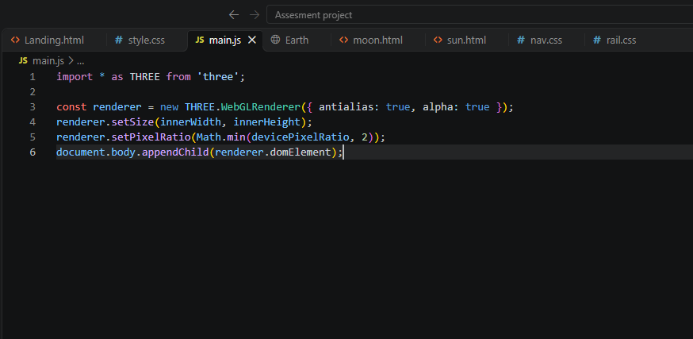

Right now tho we have declared the canvas we cant see anything as the canvas is blank
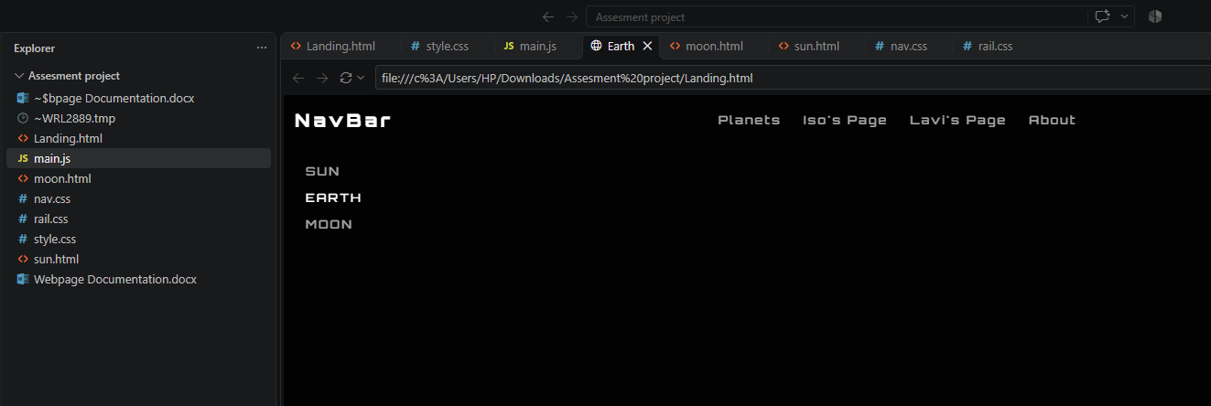

- Making the essential for scene projection of three.js
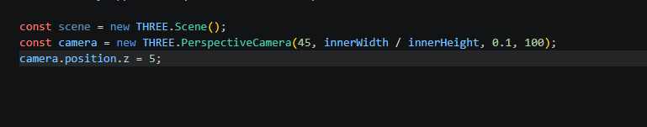

- Next creating the wire frame as a placeholder planet.

I have civent the wire frame sphere mesh points of 4 each side so it looks smooth. Howver increasing the points mean that the website loading time and response time is effected that’s why I chose a value of 64
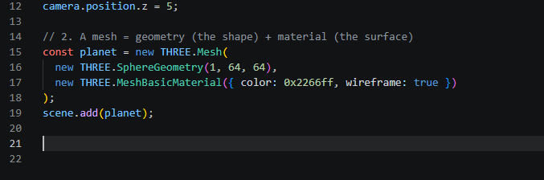
How ever having doen that still doesn’t render the sphear

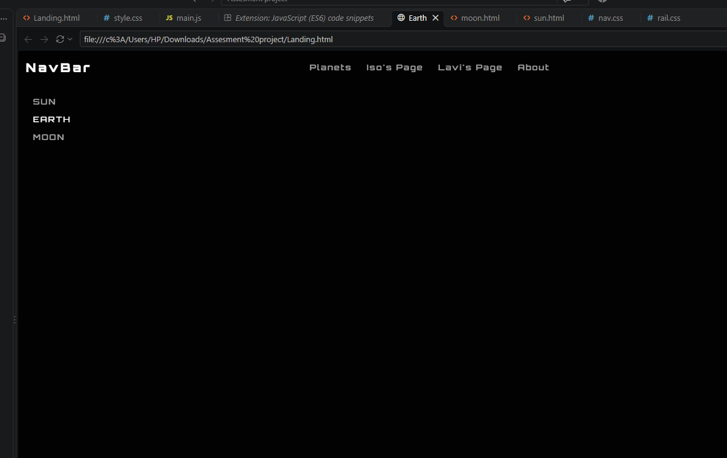

In oreder to see the wireframe sphear we have to render it. So like we do with regular programs I am going to make a function to render and render the sphear

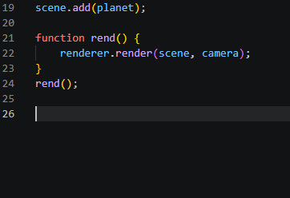

And now the result is

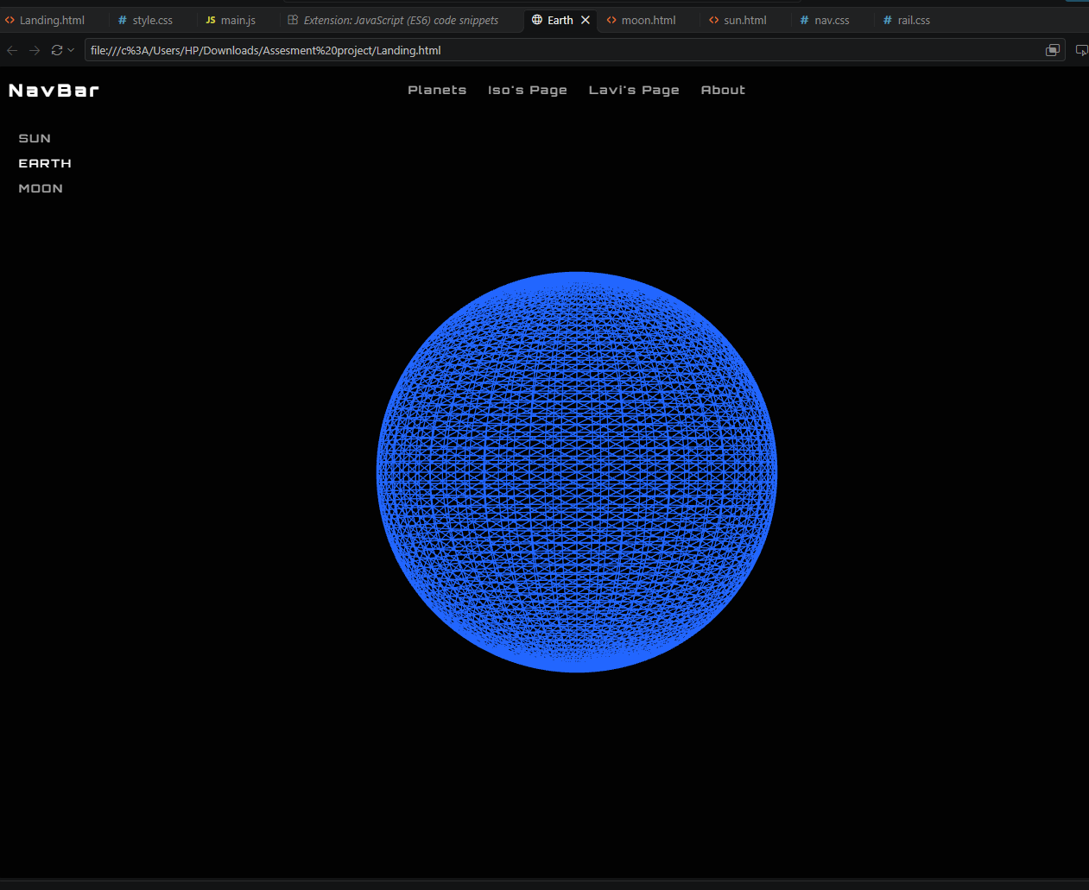

Then I worked on the scaling of the sphere so it resizes its self based on canvas ratios
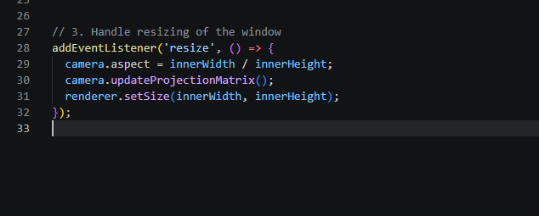

Next im going to animate the spear to turn
So on the rend function im going to call it animation for what It does.
So the sphear spins and also resizes properly but its hard to display it as a picture
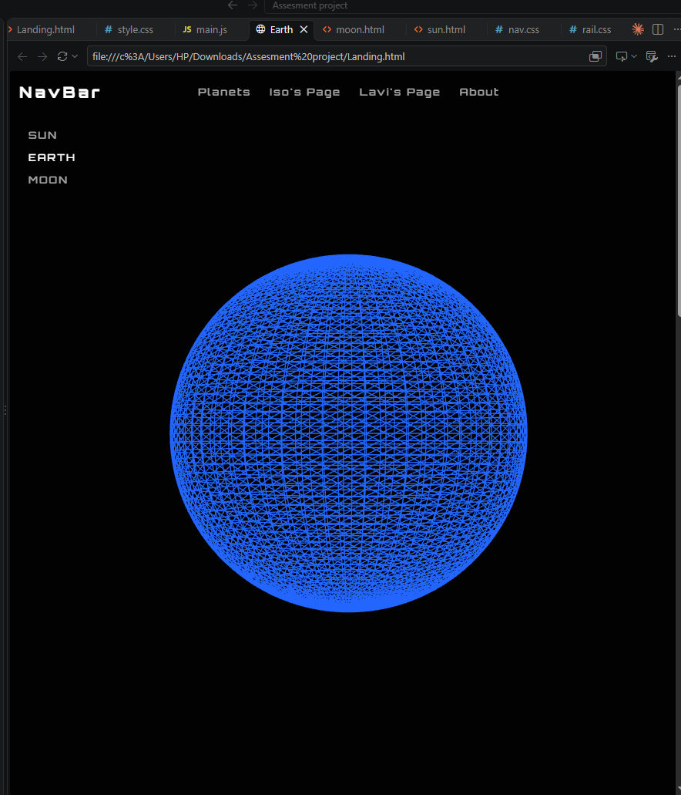

Adding event listners
So I created the event listners based on muse drag over the object to do this using javascript we call a pre built function clled eventlistner. This is special function using interruption routines to recognize what is the activity it’s going to do
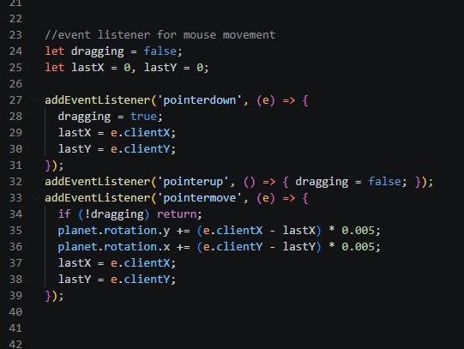

Adding texture pack to the sphear

I first called in a resourse teture pack
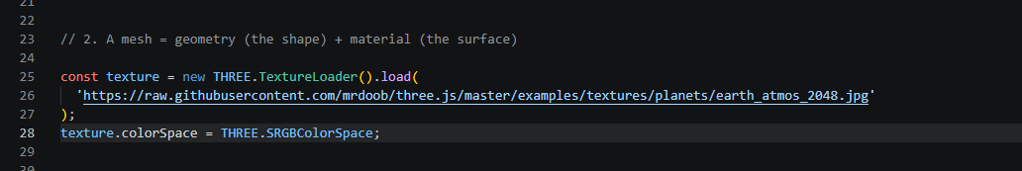
I then call the texture holding var inside the sphear creater and replace the wire frame with the texture

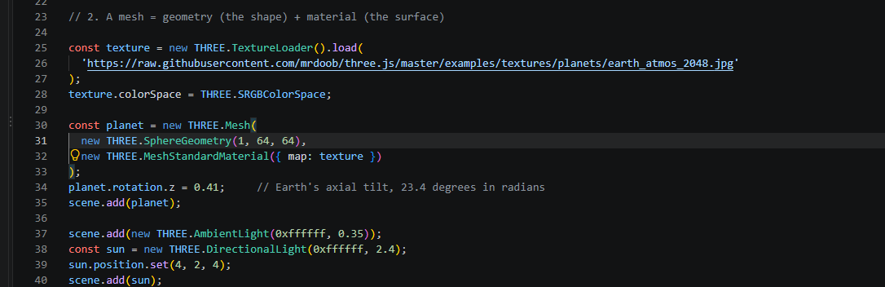I also tilted the sphere by the same amout earth is tilted
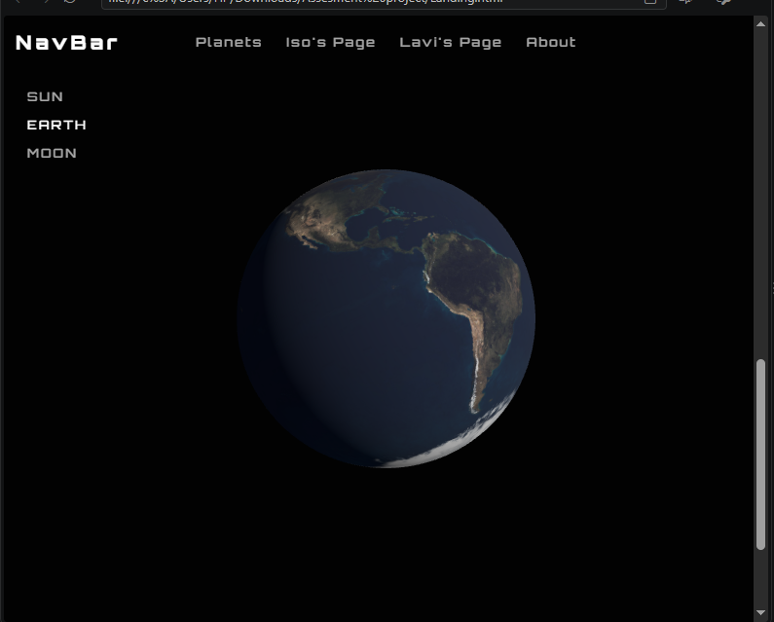

Creating scroll animations

So the initial plan is to scroll the sphear from one position to another . Iearn this skill through
https://youtu.be/rbIbvw6c53k?si=ZoSBGkl23hVRUifr. He takes us through an amzing 3d scrollable wepage
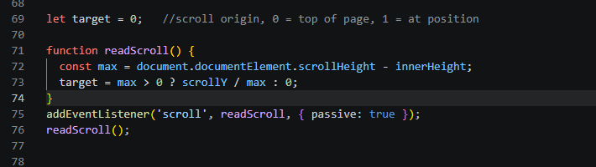
This positions the scroll lister to a point of origin to the ending position of scroll from 0 to 1 with in the full scrollable range
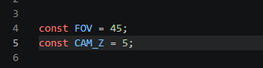
Created this at top as this controls the camera
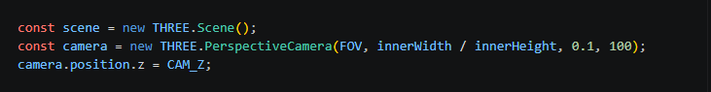
Overwrote camera scene to fit FOV and Camz to make scene

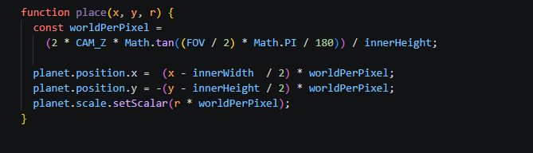
This is the apply of maths from that sees the planet in zth ais and does the calculation per peiel movment is all that is to it so this whats represented y worldperpixel
And then positions x and y are the origin (0,0) from centre of screen not pixel 0,0 at screen left top.
. so that was the piel positioning of the planet and net to define where the planet is at each key scroll position. We can make a effective scroll animation through liniear interpolation. The factors taken into consideration are x,y positioning as a,b and radius as r

Linear interpolation for smoother grapic animations
This math isn’t something I have done by heart but is followed through a tutorial however the concept is there are 2 functions to primarily place the planet and to the position it will transition to as the lay out
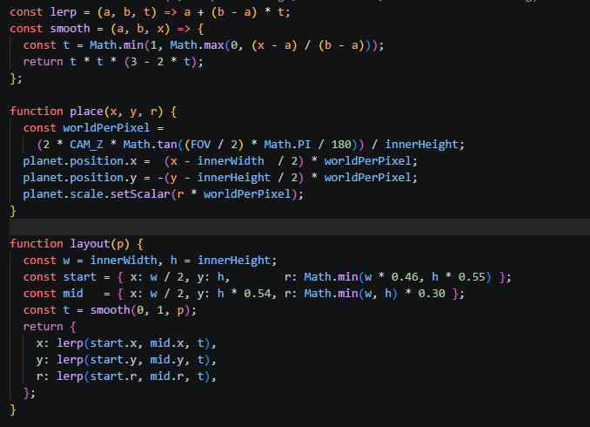
Now when e look at the site
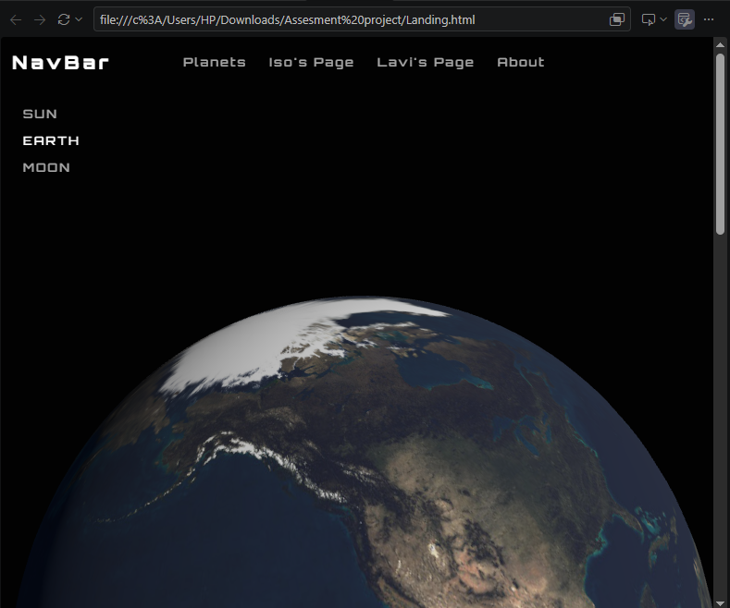
To
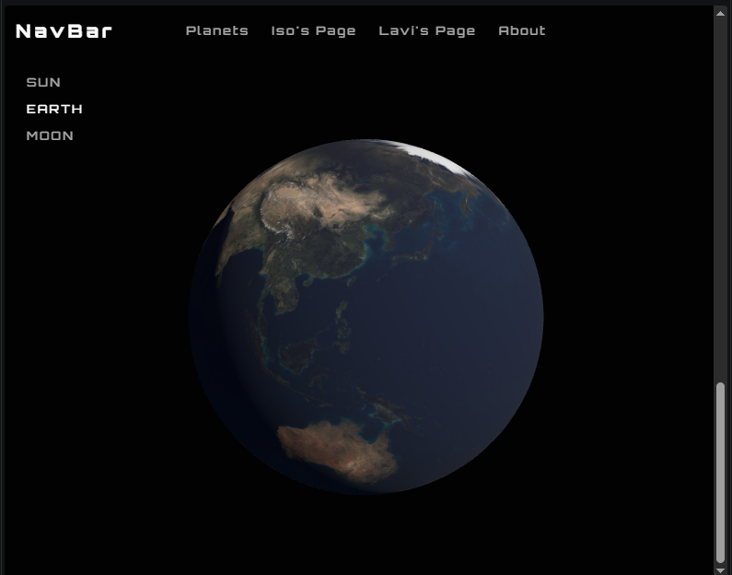

Adding facts about relative planet.
Writing this inside another class section
I am going to write the content in the pair tag the <dt><dd> tags

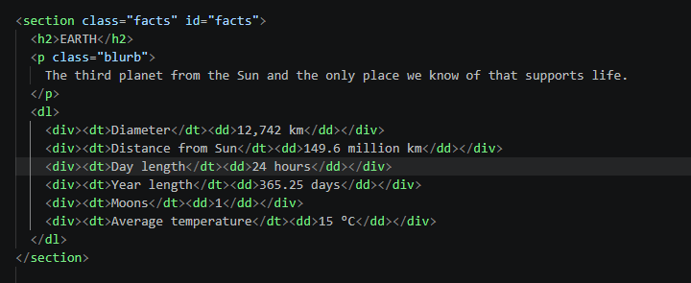
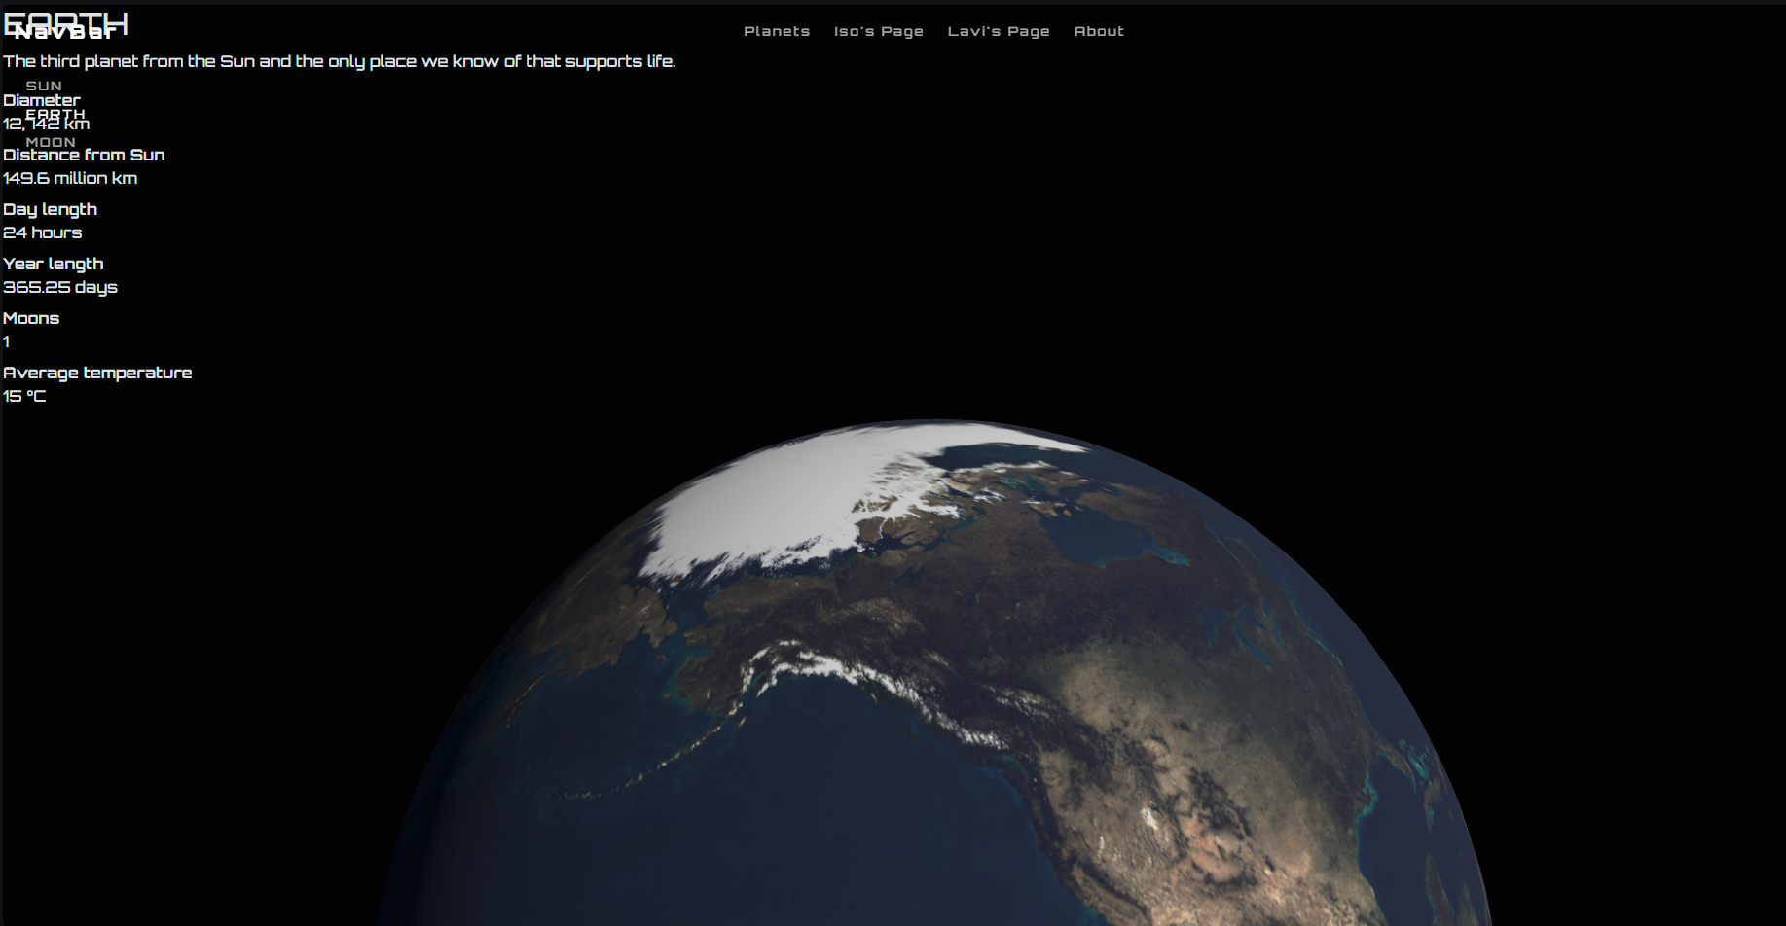
Write now all the text is clumped to the top left corner. I will use my css files to situate them on the bottom section of page

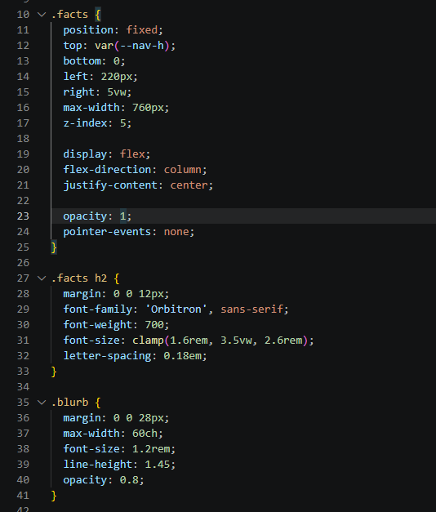
The content is placed in the middle of the screen with everything to how I want it in . however the problem is right now its displayed through out the page
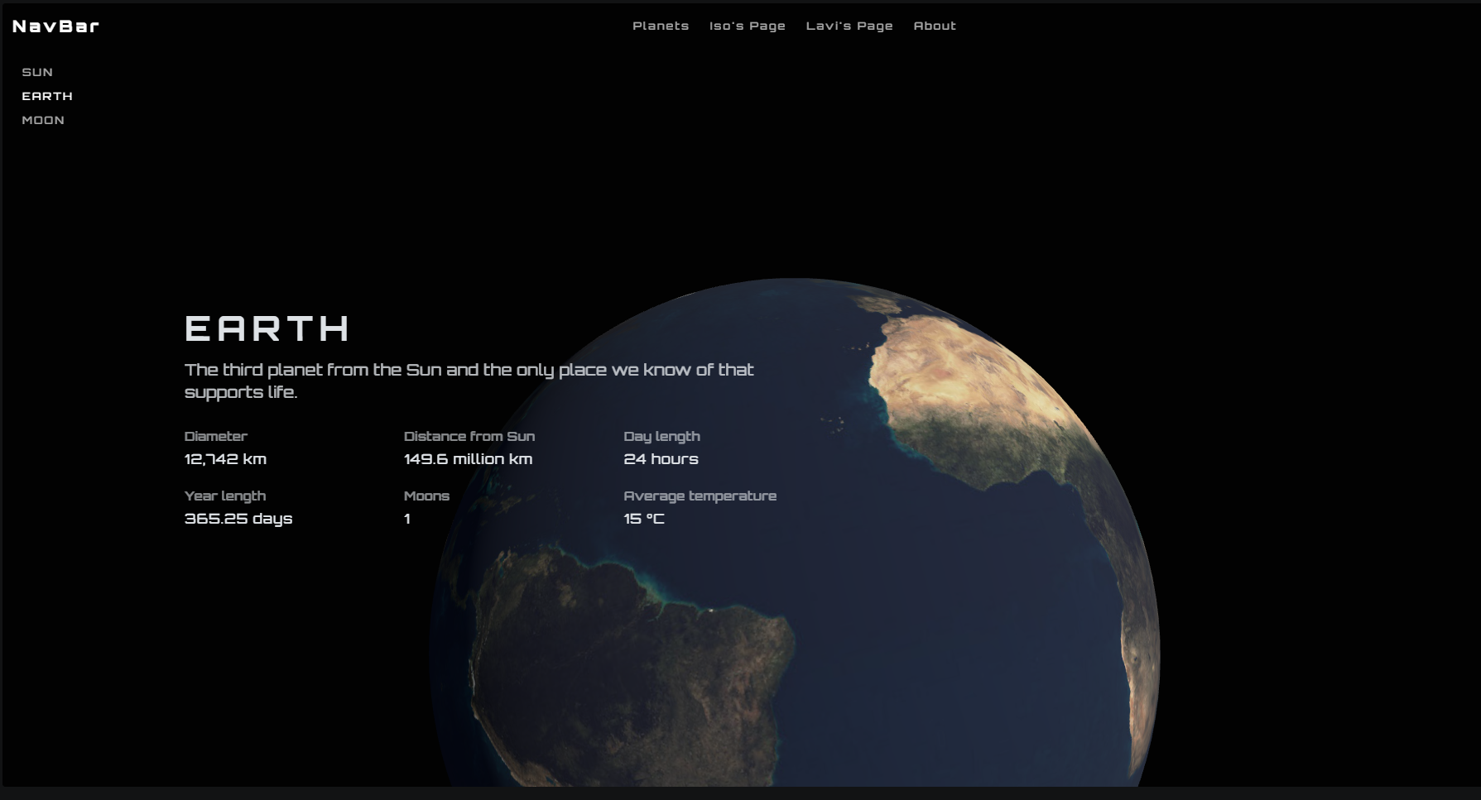
Now ill have to hide this and create the js script to increase oacity when the scroll is at max
Calling facts id in main.js 
And then I will use the progress variable to map out the positioning and will increace to full opacity at the very end. The animation happens inside the animate function by calling id and the relative filetype and its attriutes
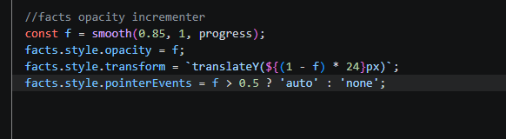
Ill set the opacity in calss facts in style css as 0 that will cause the text to disappear
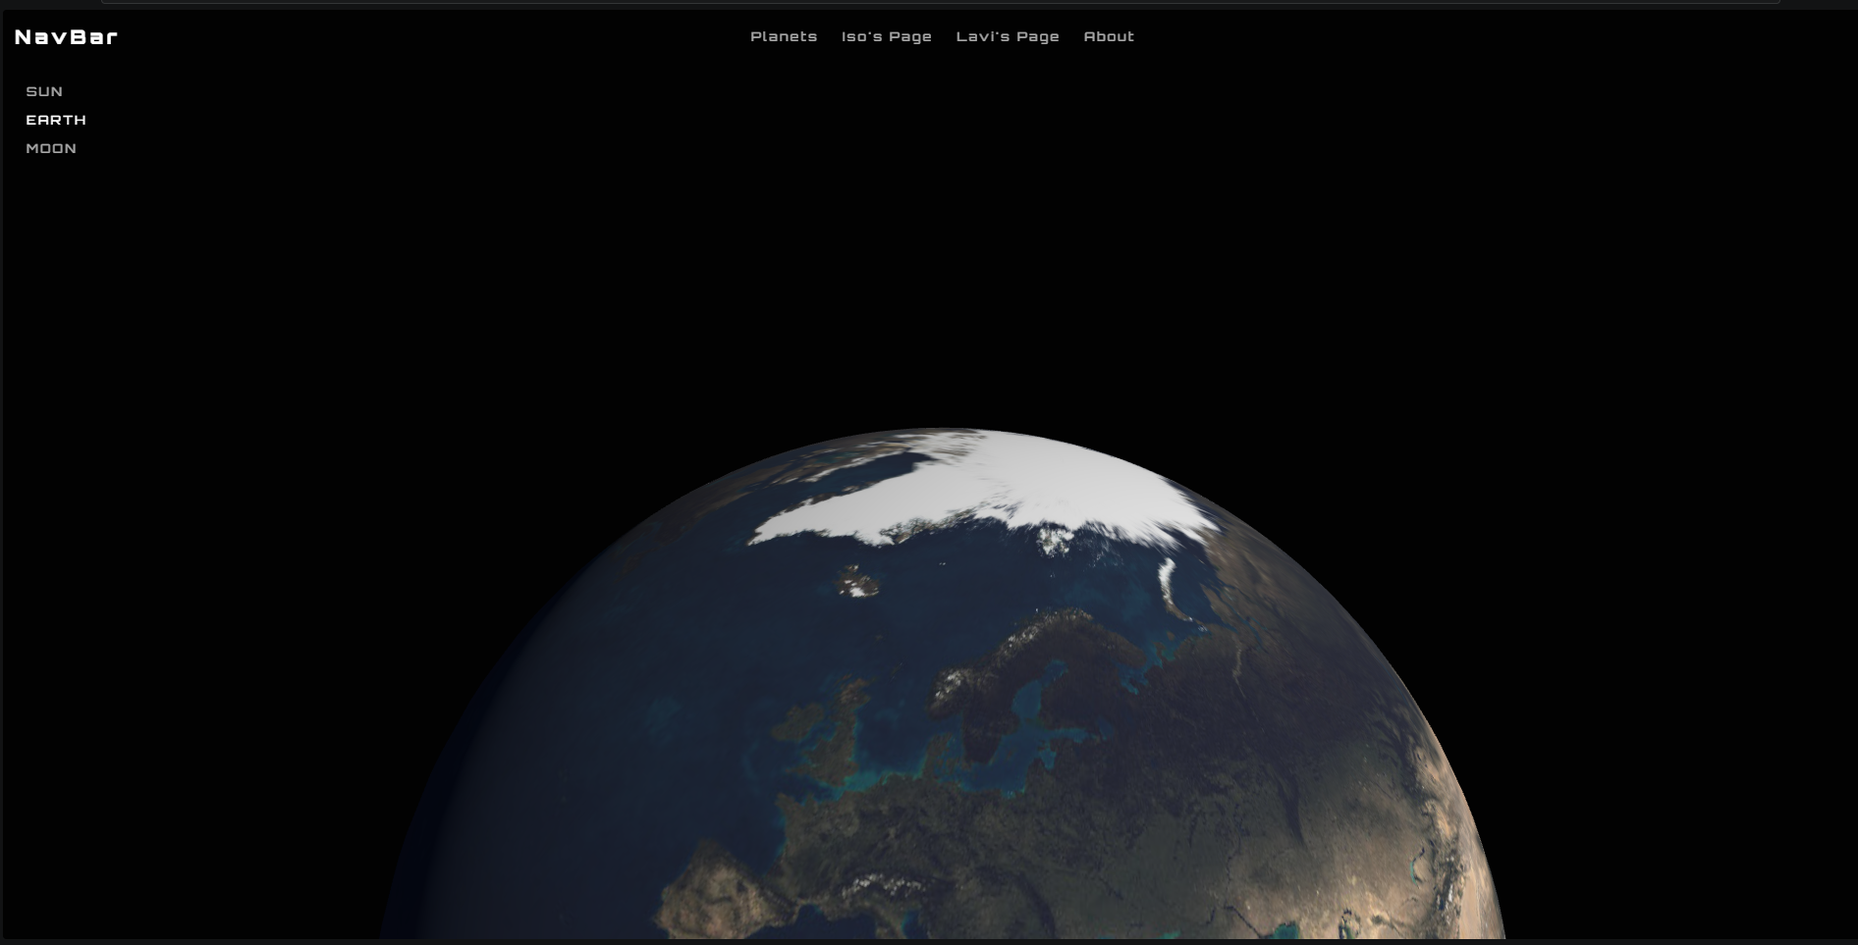
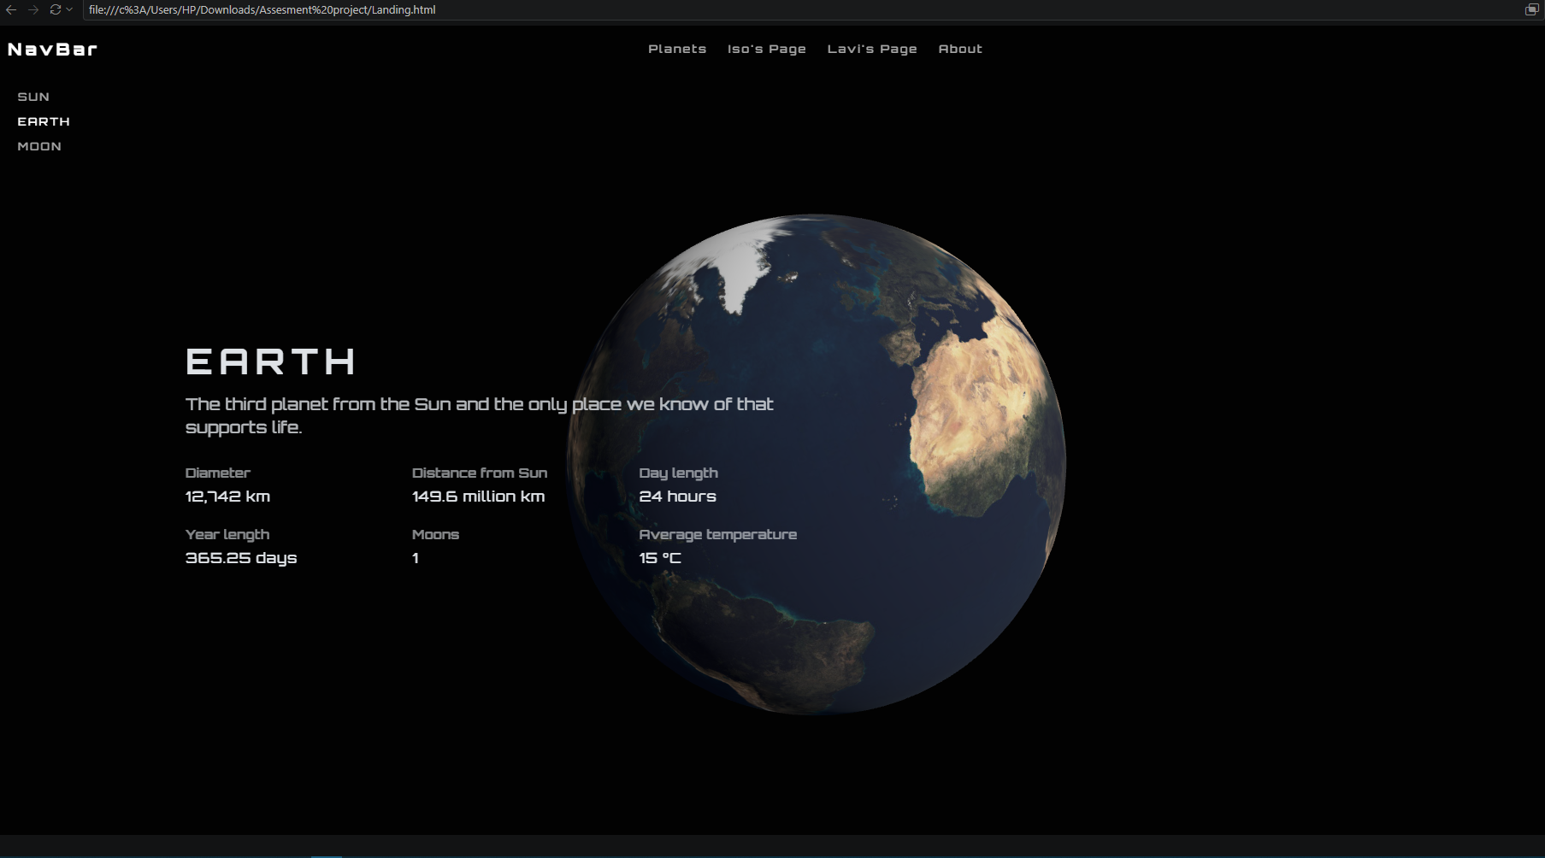
I do have a small confession to make I borrowed the texts for the blurb from google ai
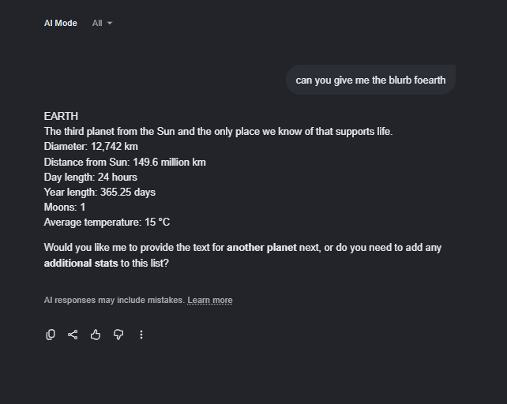
Like that I asked google ai to generate blurbs for the sun and moon as well. I am doing this out of a hurry case the hand in date for tis assessment is only about 5 days from now and since my landing page is the page that interlinks mine and my temates projects I need to be on my toes to knowing what my temates will do.

Okay.. now if I were to render 3 pages by writing the sape scripts and css files would take a long time hehehe. Obviously that is now what I am going to do. I am going to create 3 different instances for which will map out the data to relevant places. So basically I will restructure this as a template place holder in the js file and it will load the appropriate js construct store according to the content the page calls on.

Creating planet Data stuctures to load components
I created another js file called planets so this is the data hold structure
And in that I call in the api for the texture packs and the create it in a structure that could aquire the data structure in the main files.
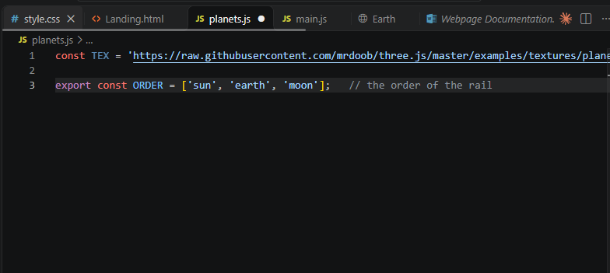
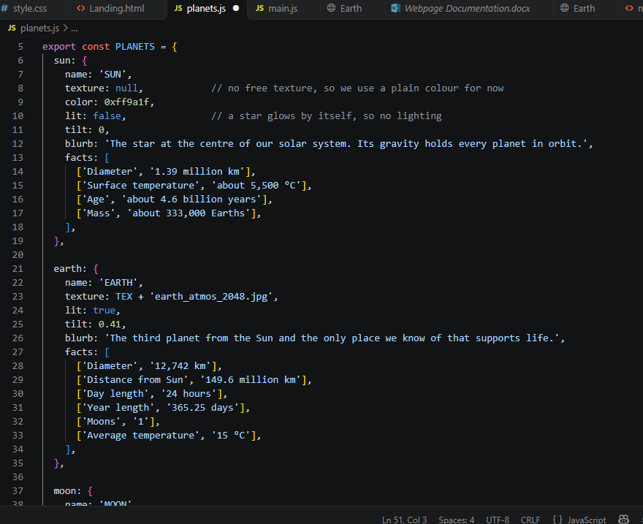
The repo that im using doesn’t have a sun texture pack. I will find a texture pack once im done with the project I just need to finish this an I’ll do that as a clean up.
Okay so now that we have established our data structure I have to pass these to variable place holders in both html and main js. This is so that everything Is tidy and is editable in just one page.
Now I’ll start of by creating the placeholders.
First lets start by passing the content to the html
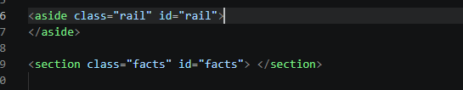
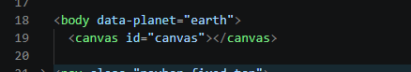
Okay now everything is cleaned up so now we are essential backdown from oth the facts and the side nav bar
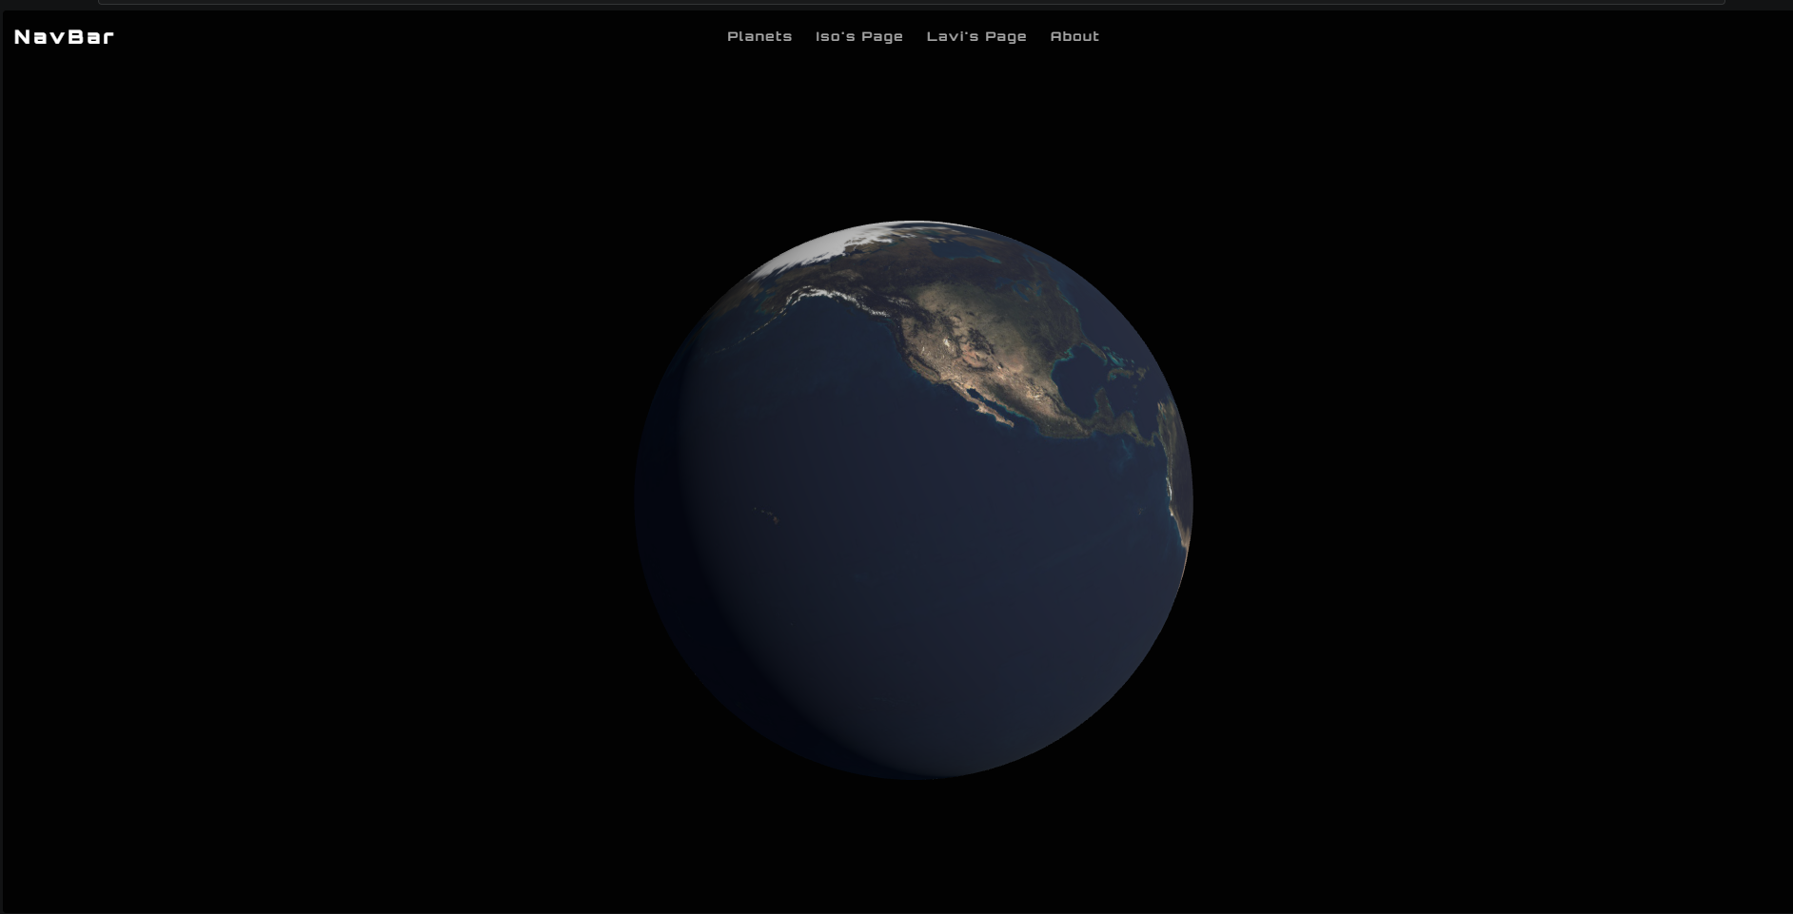
Now we write the sections in the js file and it will fill the place holders.
In the main.js we import the 2 parameteres we exported in planet js and with that we can structure the id of the side navbar and the facts section.
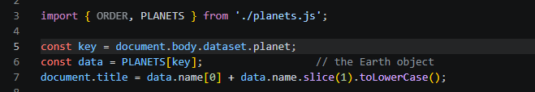
This is to call the id of the page for example if the key was the 0th index in the array that would be the string value “sun” and with that then we can read through the planets structure and read values based of that to get the content.
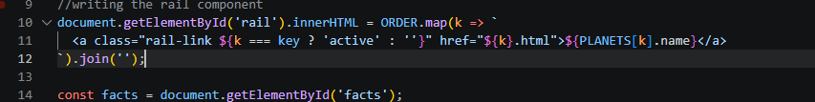
This didplays all of the planets displayed within the array planets in plantest.js
The styling Is still handled by the rail.css it would still look the same.

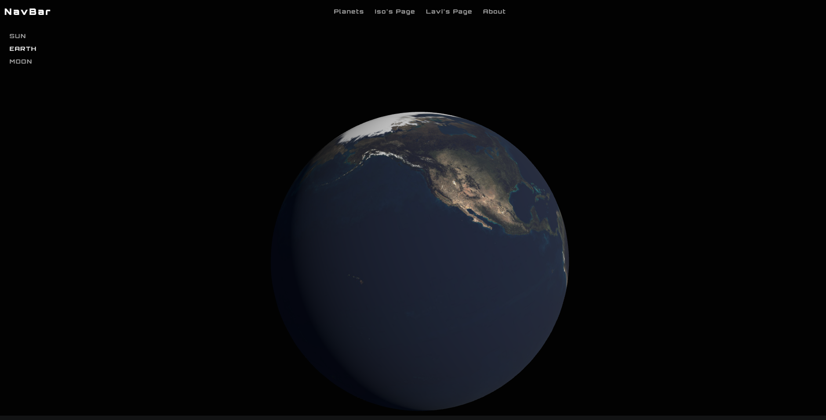
Now like that I will also do the same for the facts id
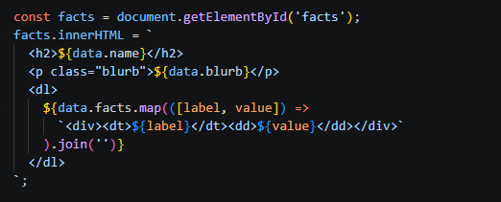I wrote this under the already exisiting call for the id facts. This will display all the facts content as it was already for as many labels and values existing within the planet structure. For example in planet earth it will display all that id did earlier.
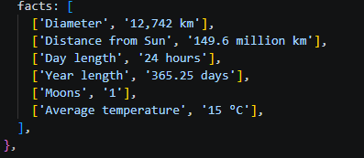displays all the content in the planets.eaarth(data).facts and all off its branching place holders in the structure.
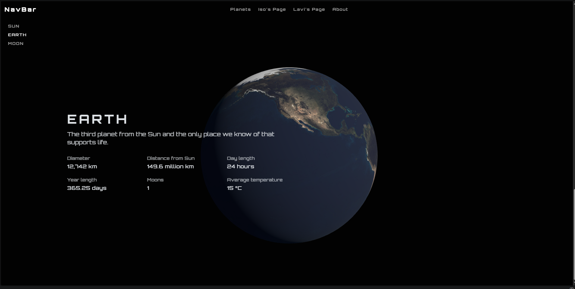
Now to do that with the other 2 placeholder html pages I have created for the sun and moon. Iwill copy the whole of ody in the landing page .html and will assing their place values in the oder list.
I did all of that and the pages run smoothly. However the only issue is that it displayed the earth texture pack. This is my bad as I haven’t yet changed the textures to hold the place holder texture pack
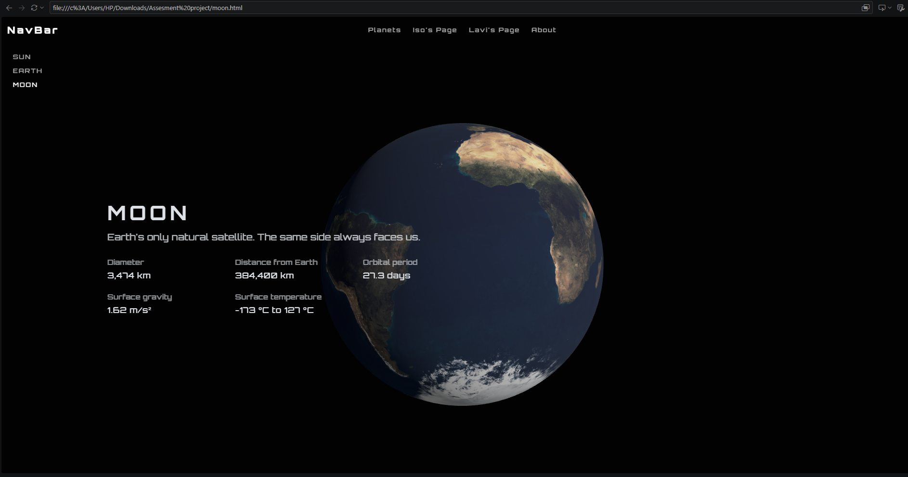
So in section 2 planets in main.js iw
Calling the placeholder to file name
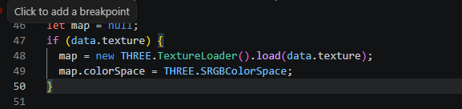

Creating the warp
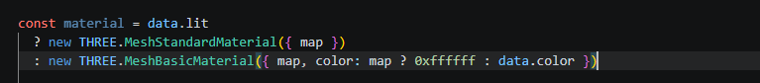
Now calling the warp on the sheare shape
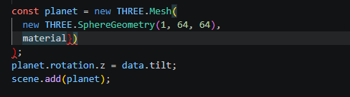
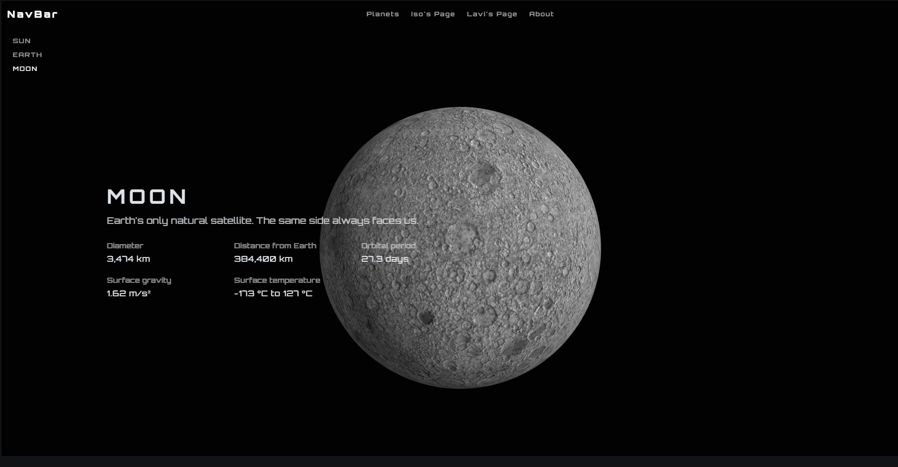
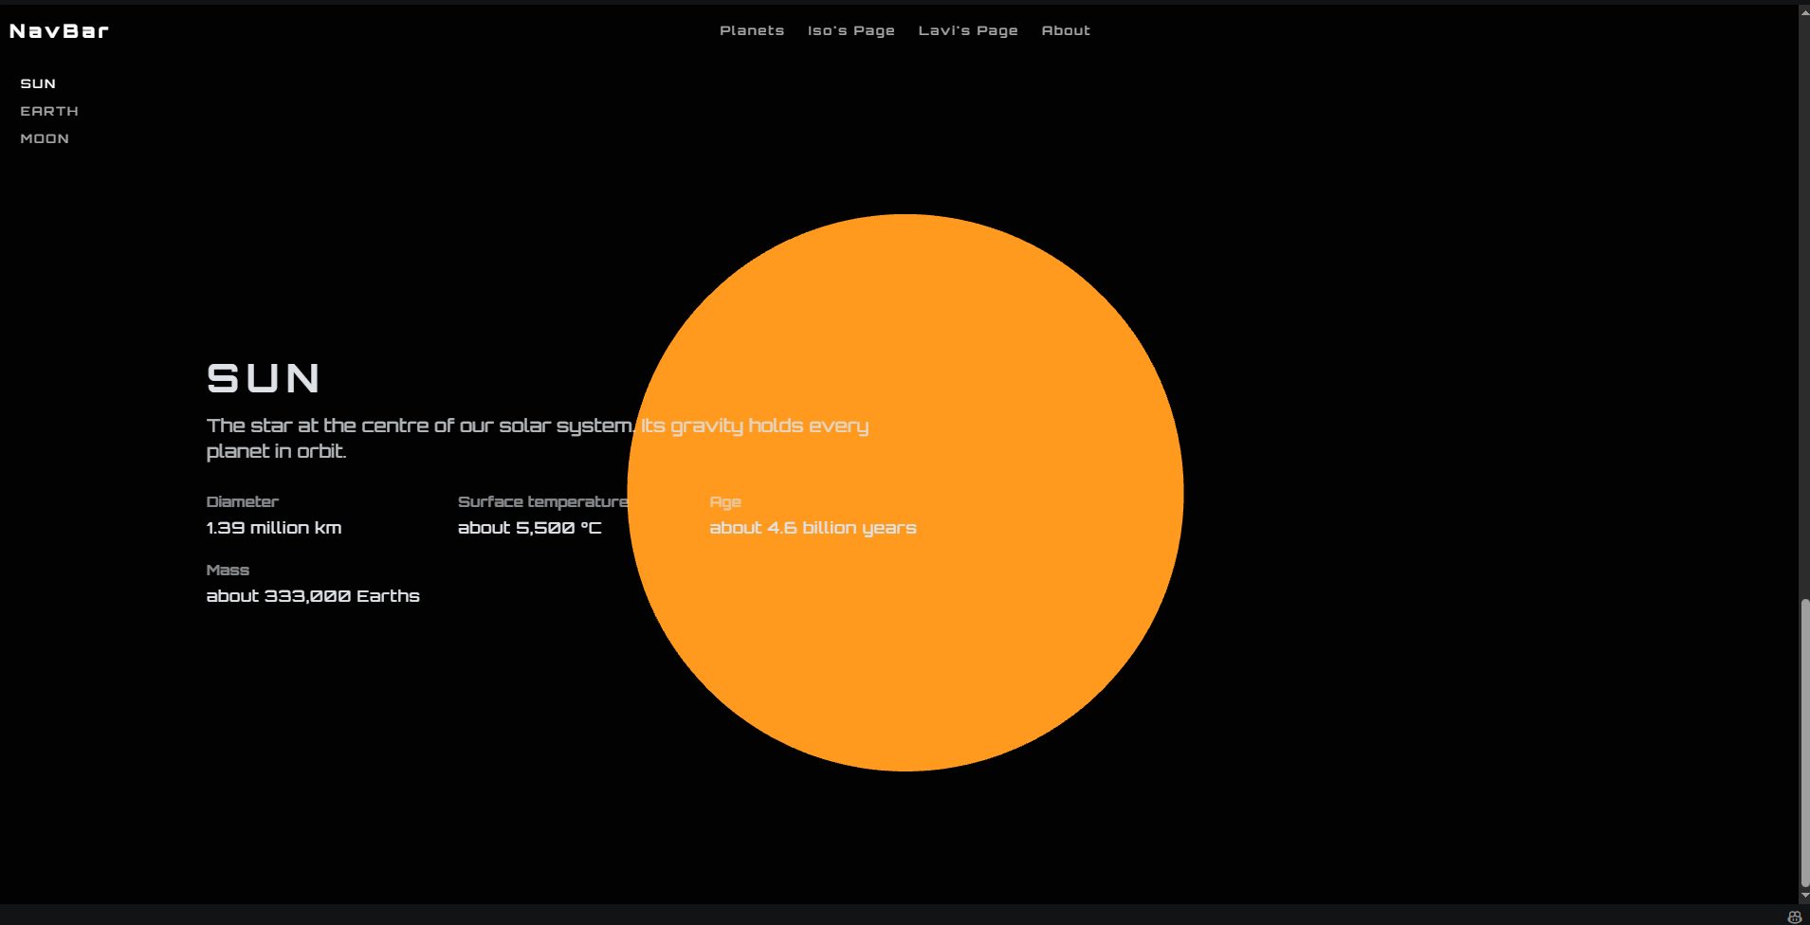

Next up cleaning up and setting up nice font behind planets and finding texture pack for the sun.

Adding huge planet name text
Calling the name of the page in main.js

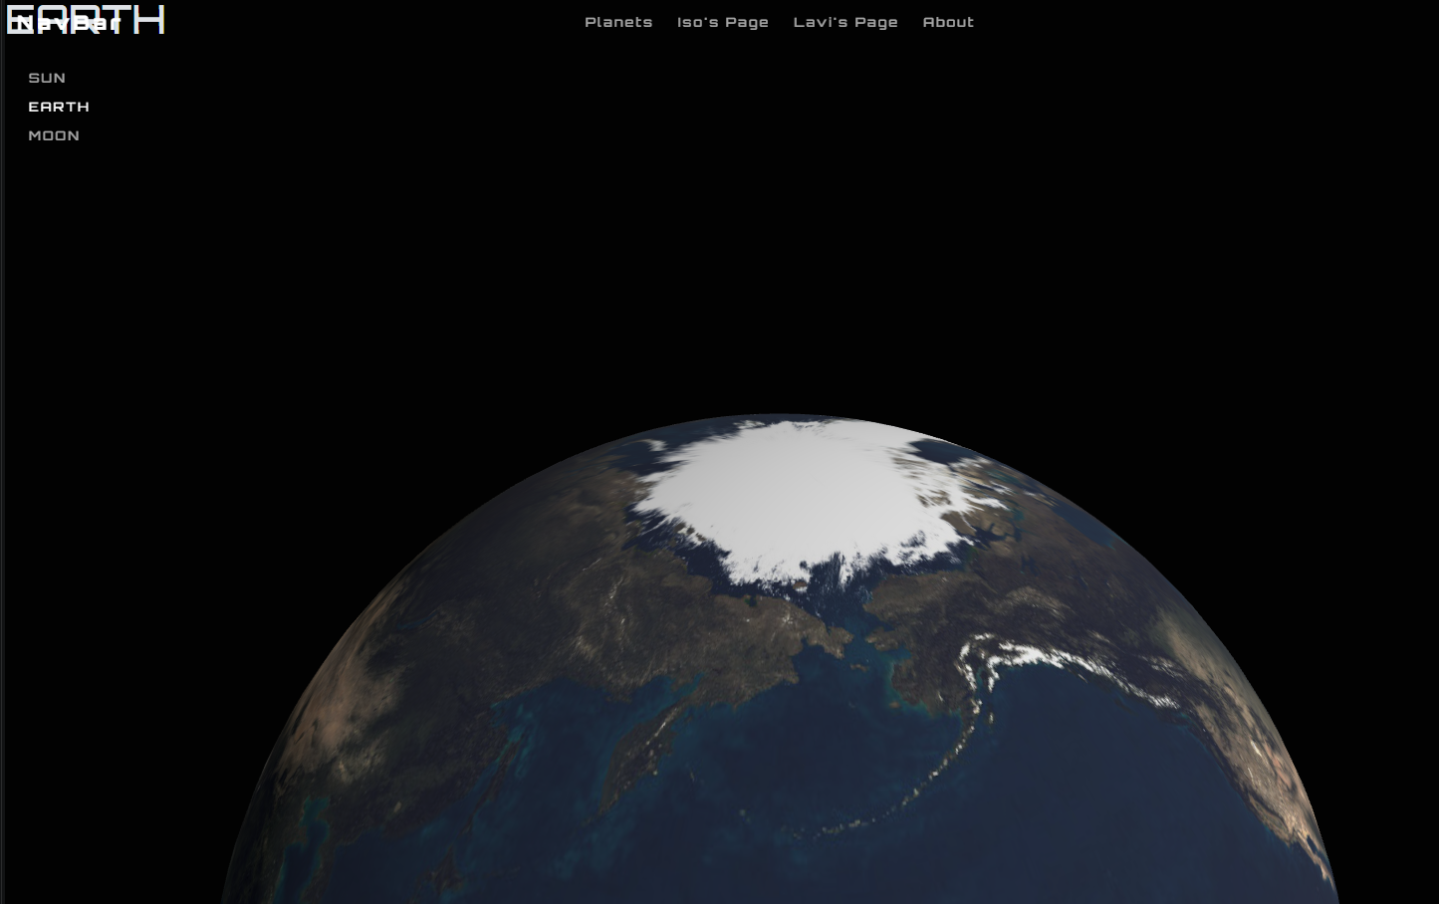
Styling the header in style.css
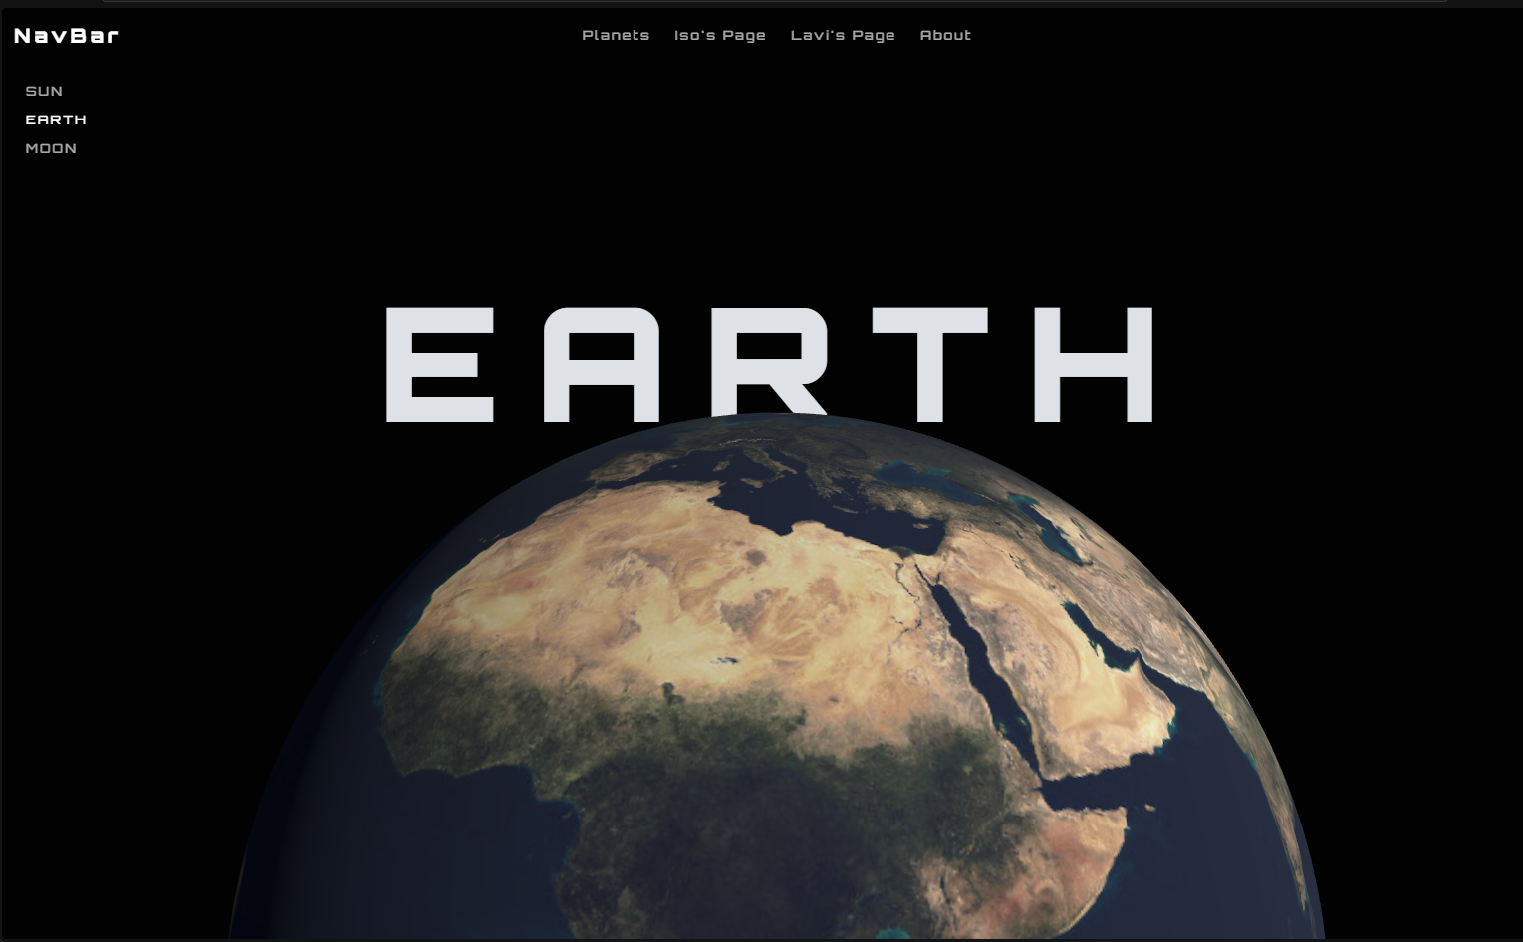
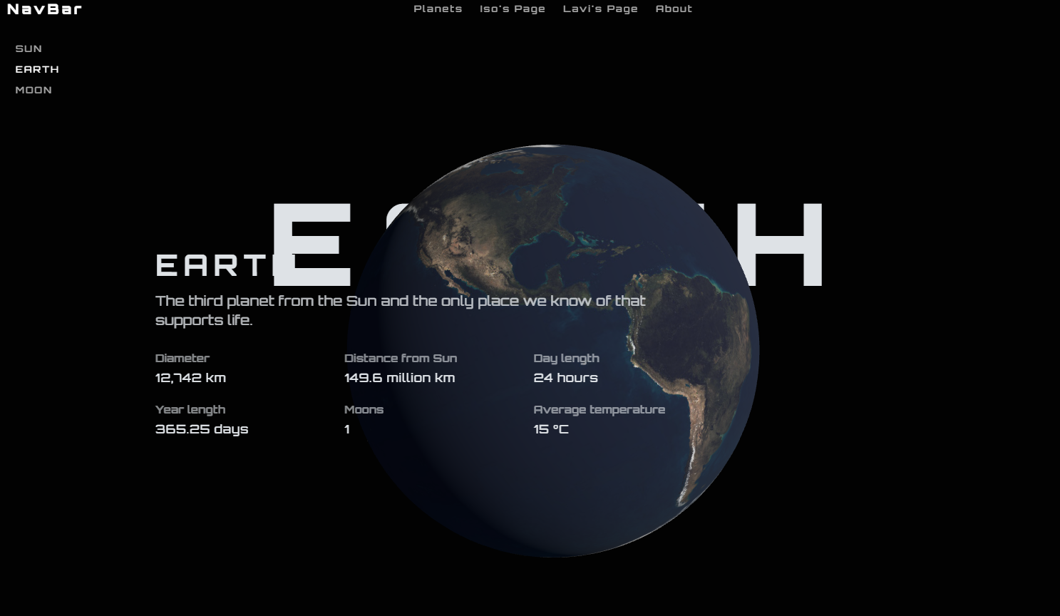
Text needs to disappear so I will write the js file to disapearat half point of the verticle axis
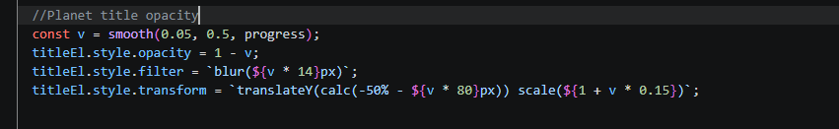
Now:
It looks like this
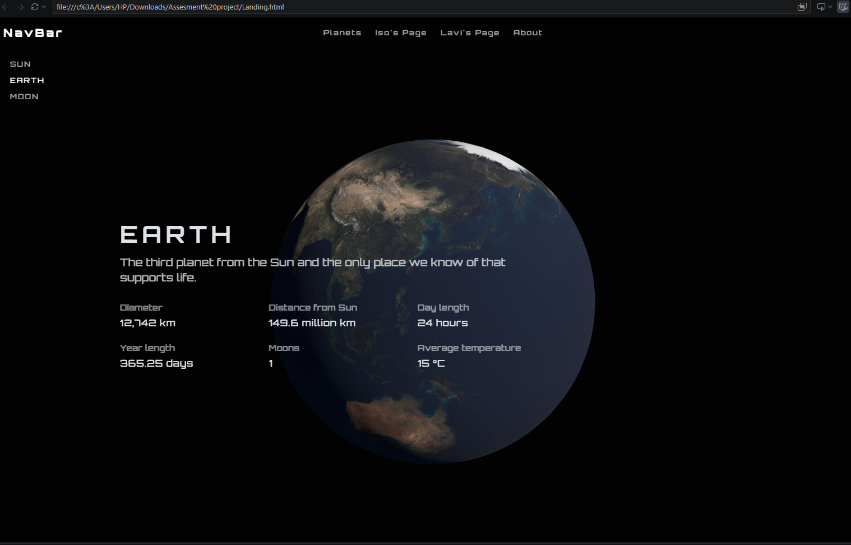
However I didn’t like the transition
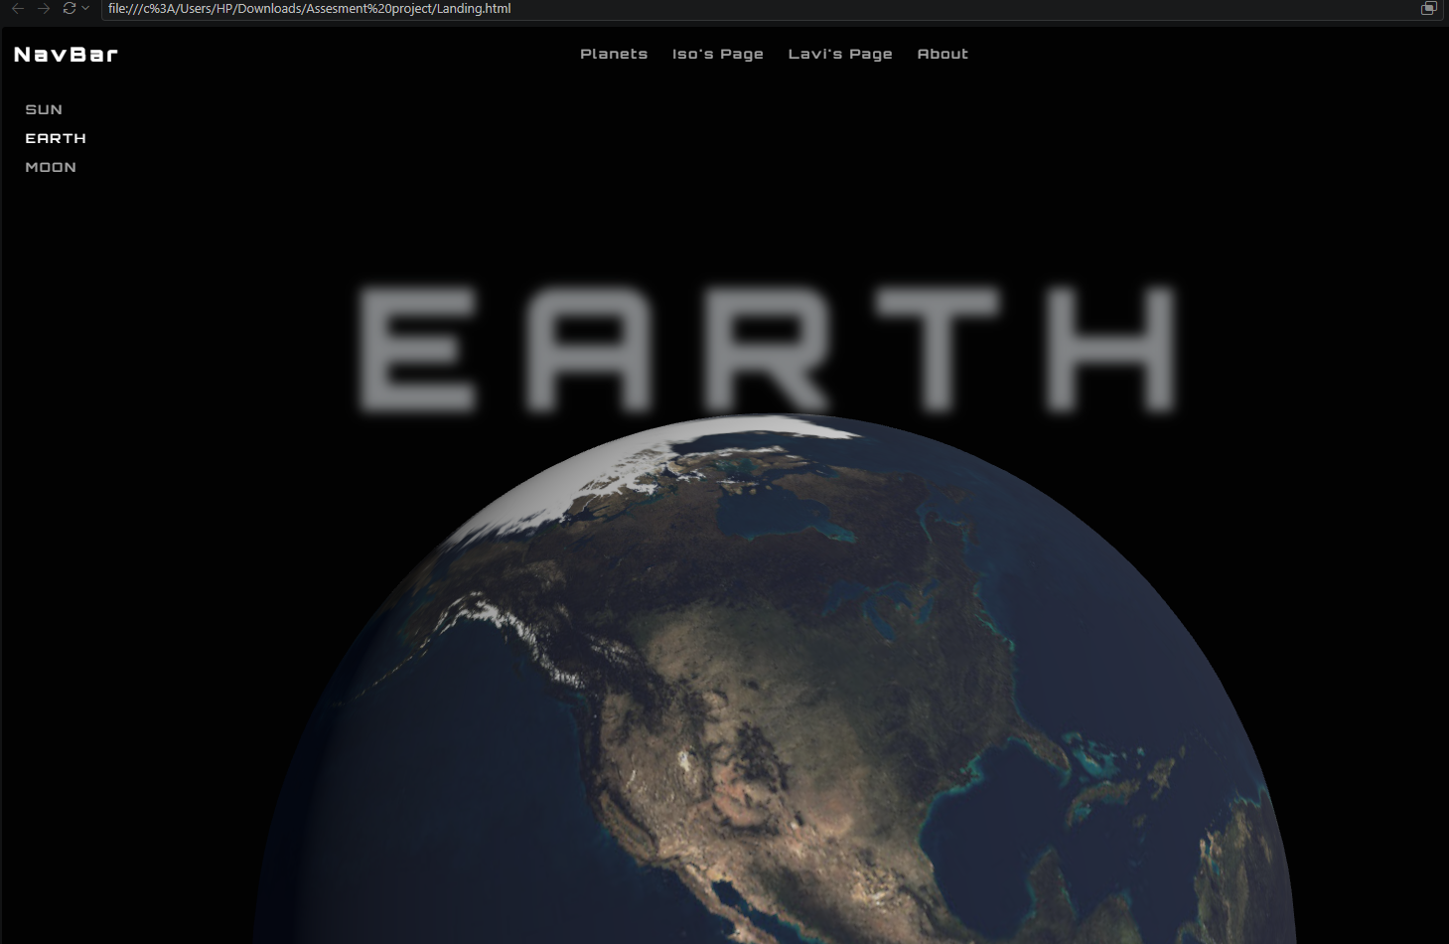this is hat it looks like at the moment I will come back to this for the clean up. As the tutorial taught how to use the blur effect for these transitions I’ll search up another cleaner fade animation.

Now another major section has come up as one of my teammate also needs help with their page and I am now informed that he is doing something that’s slightly related to to the planets so what I have to do now is put all the written tags into a section called hero and adust the scroll animations based on that .
This is fairly ok as I have to find the places to change however once im done I plan on making a carousel to link the page to my teammates site about an artist
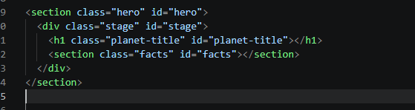I created the section for hero so that will e my plantet and blurb
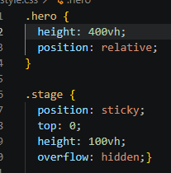 created the area for a section as a verticle height 400 so there is room for the scroll effect before showing another section. And the stage is going to be the place I place my canvas on to so everything is dynamic the same.
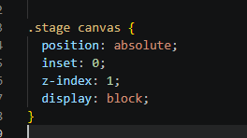I cereated the new canvas inside he stage for the hero section
Now evertything in the page is dispersed. Next bit is the java scrip fix as I have to correct the math to take the height in comparision to just the hero section and not the whole html page
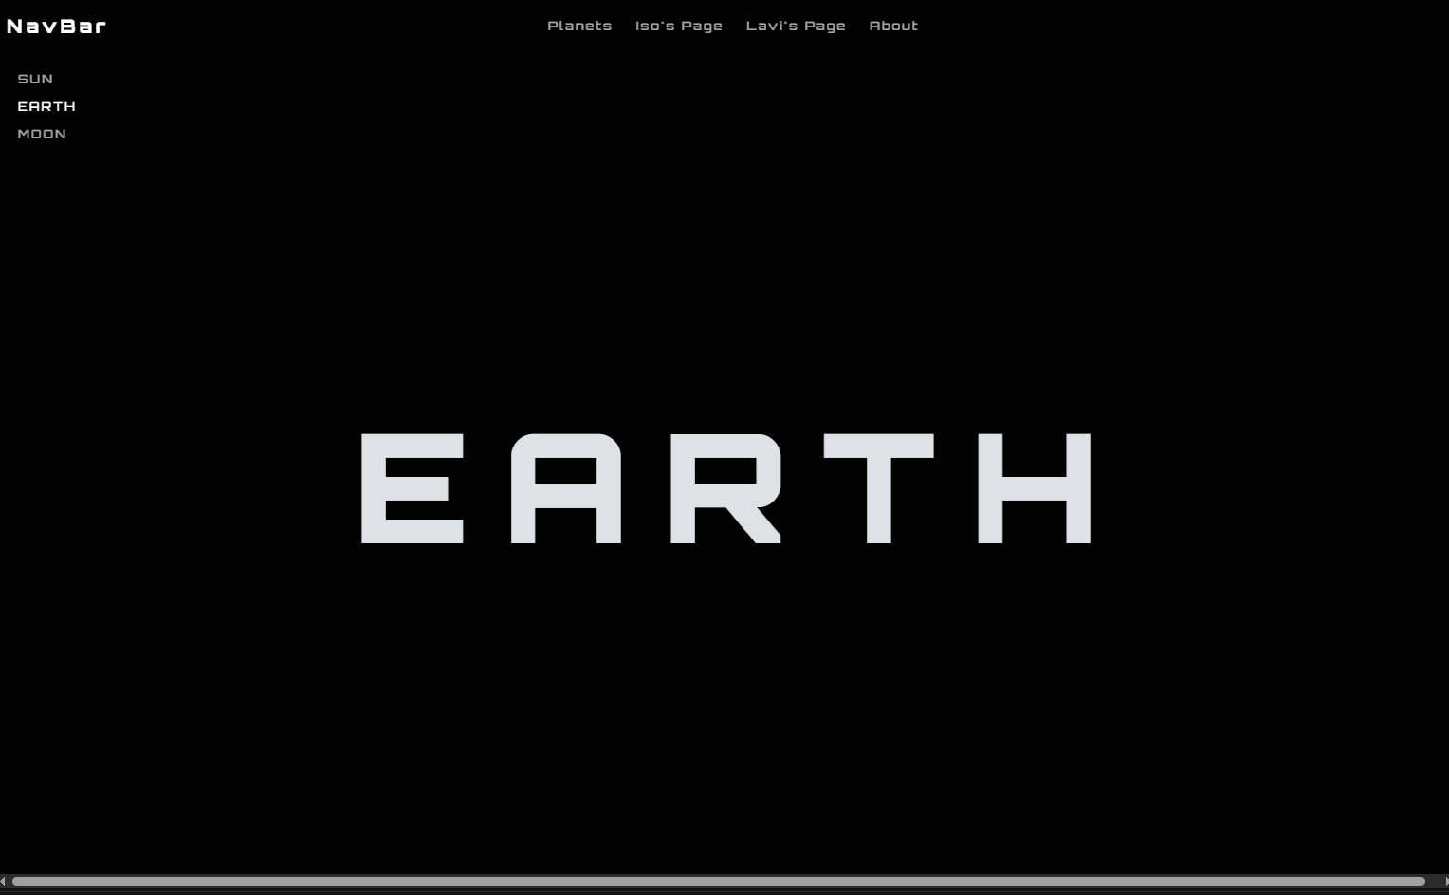
Now I write the function that inherits the canvas in stage inside the main.js
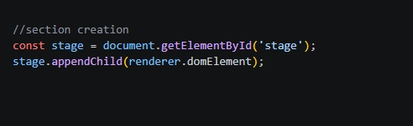
I replalaced the earlier canvas on the body 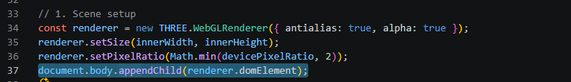
And then called the render function in side stage
Now everything is backtogether. However to stop it going haywire when I add other sections in I have to edit the scroll function so that this scroll works only for the section height. First I load the id of the element.
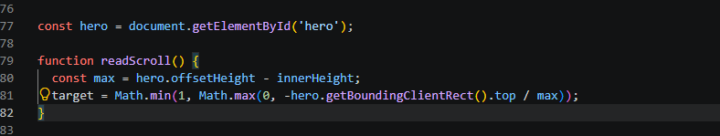
It now looks at the hero height and it behaves exactly like it did earlier

Working on carousel for teamwork link
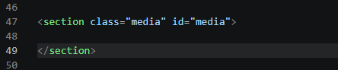
I will only apply carosuel to the earth html pageme
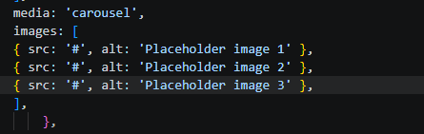creating image place holders in the same format as I did with the blurb.
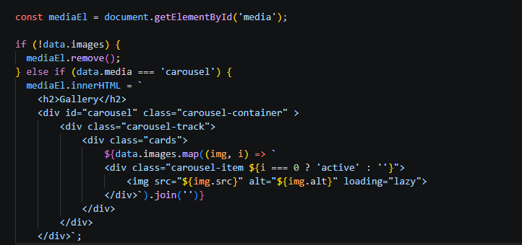
Iput the images and caroucell css using https://www.youtube.com/watch?v=tEGapA8iEkE this youtube tutorial
However following this tutorial lead me to a small issue
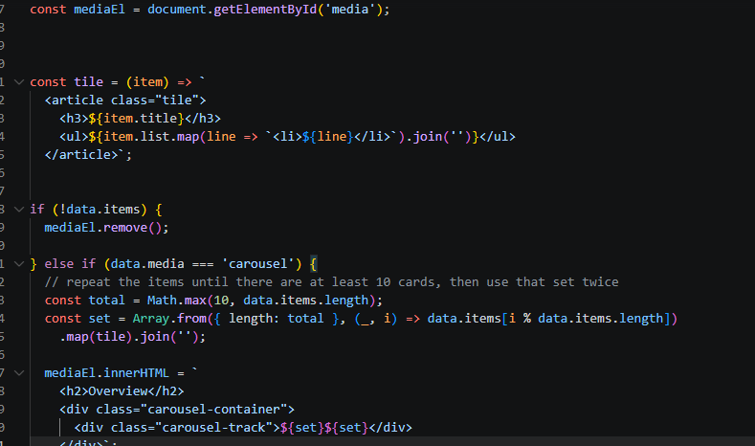
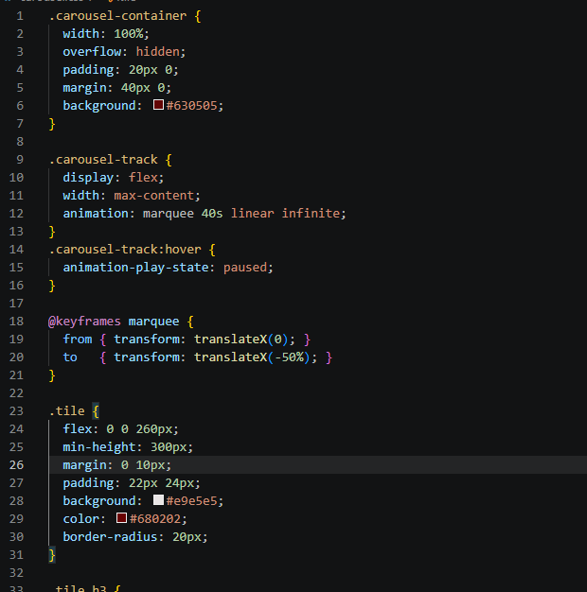I used different colours to understand the layouts
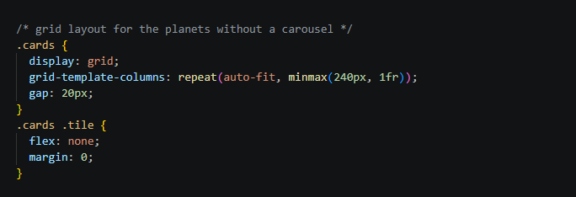

Creating the grid layout so all of them are in a row
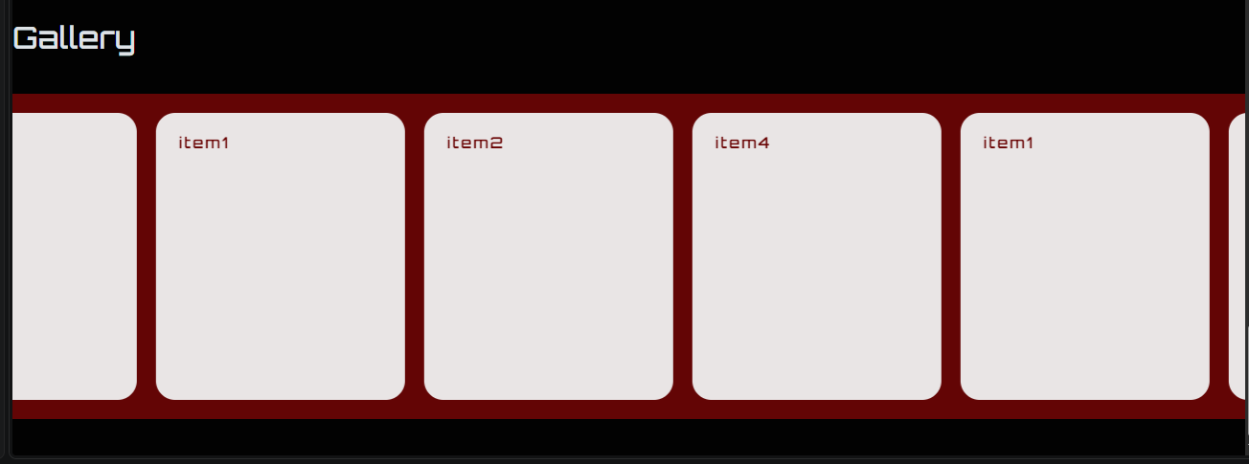
I will add images at the end when im polishsing the page
Next I will create the link to Lavis page.

Lavi’s page link section
Description
Lorem ipsum
Like I did with the carousel I made a new section on earth html
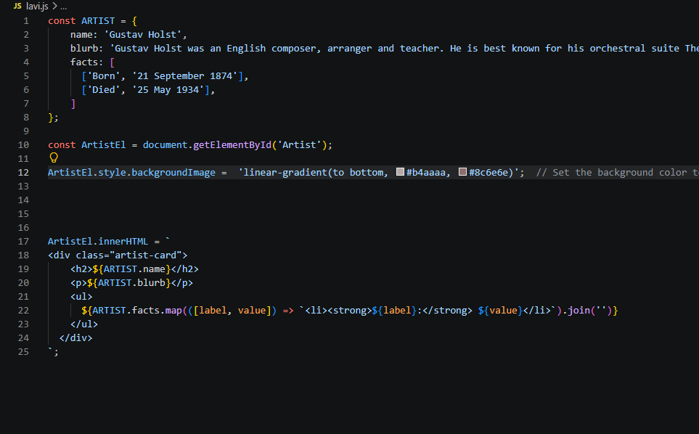
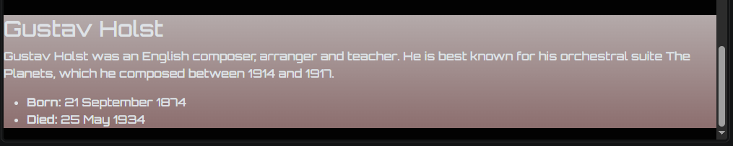
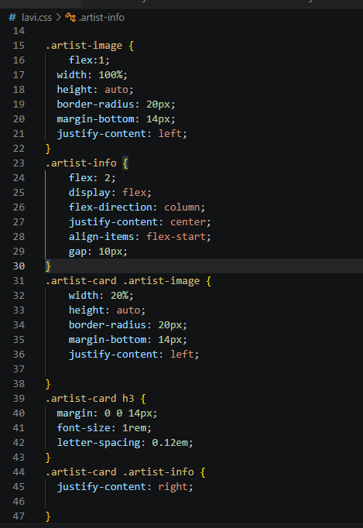
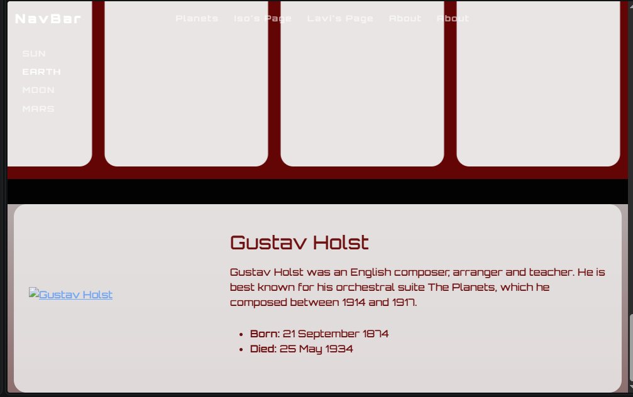
After add ing image

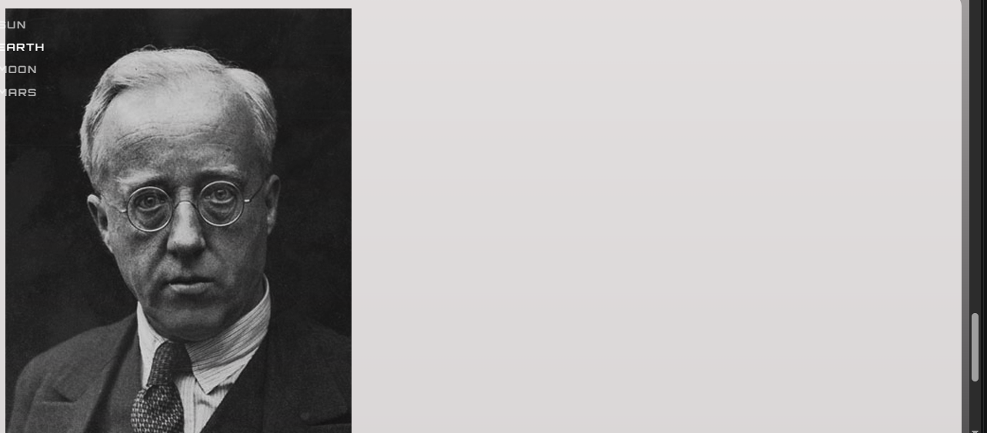
Increased bored radius
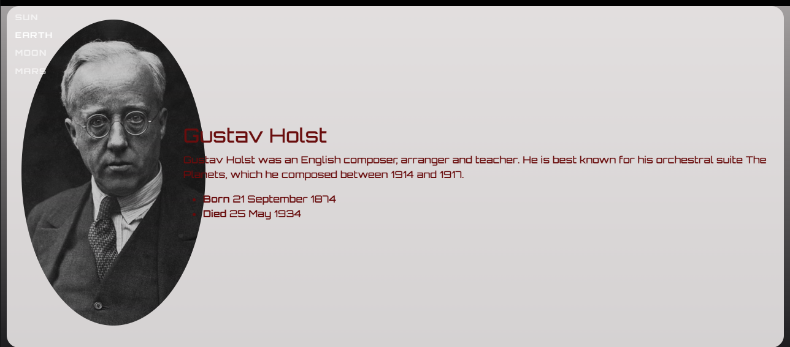
I 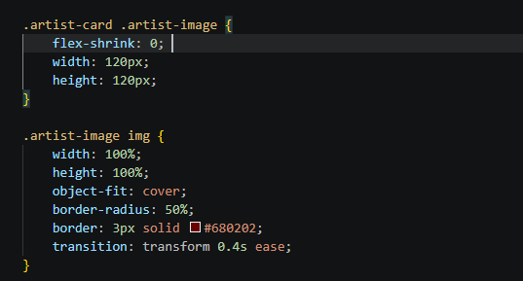

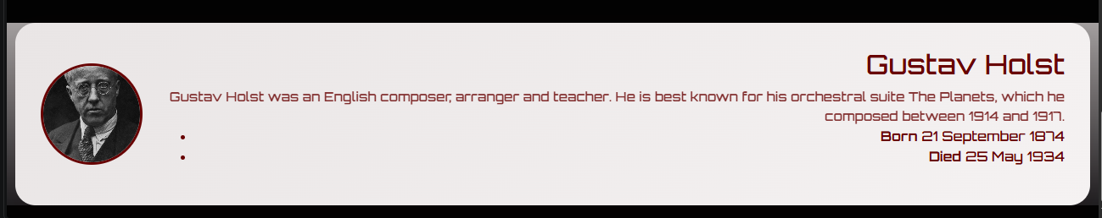
There are 2 unwanted bullet points ill get rid of the later .
To increase dynamic functios I createrd a small hover effect here the card angle on hover with the image
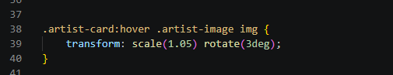
Now I will clean the color schematics of the 2 components and thenwork on cleaning up and hyperlinking.

Adding images to carousel
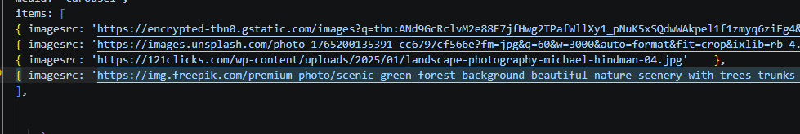
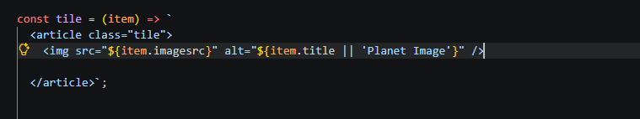
And I ran into an issue ecaus e I haven’t given a fixed tile size
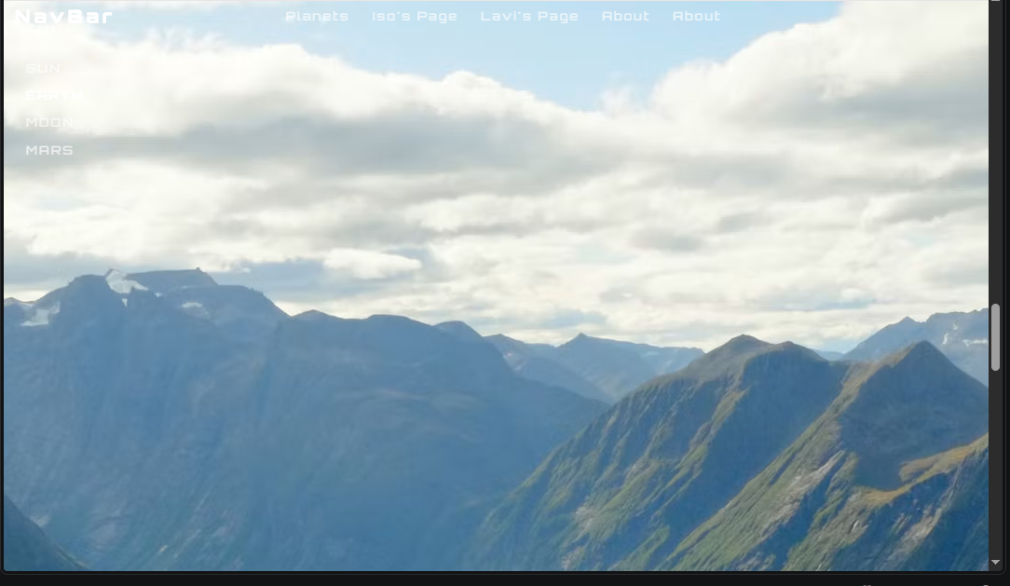
GAVE THE IMAGE SIZES A FIXED SIZE AN IT CLIPS THE SAME SIZE
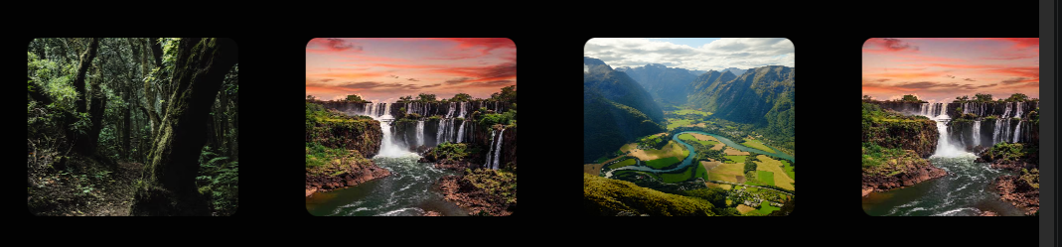
NOW FOR GUSTAV HOLST

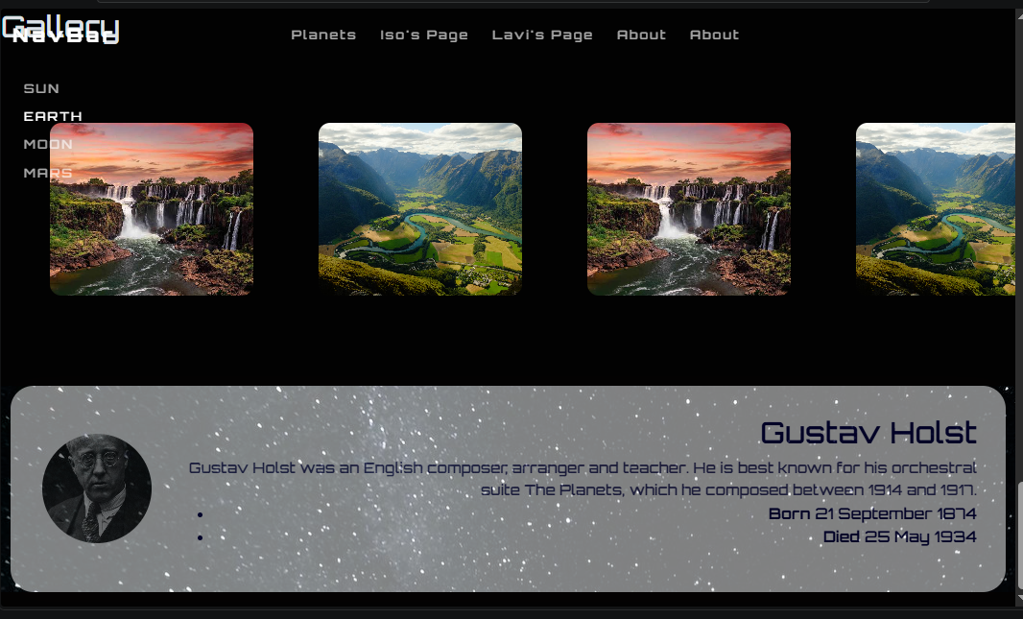
As you can see I have added a star background but more than that the nav bar and rail come off as disturbing so what I ab going to do is fade them as we reach the bottom of the hero secton
In main.js I have to do the same with what I did for the fade animation
